A Melting Pot of Architecture and Construction:
Historic Inalahan Village

Introduction
On the southeastern coast of Guam lies the quaint, peaceful village of Inalahan. Guam the largest of the Marianas Islands is located in the Western Pacific Ocean at 13 degrees latitude and 144 degrees longitude. Guam was discovered by Ferdinand Magellan in 1491 and soon served as a supply stop for Spanish galleons crossing the Pacific. Spanish influences quickly became wide spread on the island seen in changes of the language, inclusion of Spanish foods into our diets, and the use of Spanish construction techniques in the building of homes, roads, and bridges. By the start of the 1900’s Guam became an American possession and American influences started to appear on Guam. The island was captured by the Japanese on December 8th 1941 at the start of World War II, until the island was liberated again on June 21st 1944 by the Americans. From 1945 until the present, the Americans presence on Guam has continued to shape the landscape of our island.
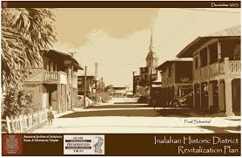

About This lesson
This lesson is based on the National Register of Historic Places registration file, “Inarajan Village” with photographs and other source materials provided by Estorian Inalahan a book by Judith Selk Flores,and the Guam Preservation Trust. Marie Sn. Castro, a teacher, and Thomas F. Terlaje, a teacher, wrote this lesson. This lesson is one in a series that brings the important stories of historic places into the classrooms throughout the island.
Where it fits into the curriculum
Topics: This lesson can be used in History of Guam class, American history, Chamorro class.
Time period: Mid 1800’s through present time
National Council for the Social Studies (NCSS) Standards
Theme I: Culture Standard B – Students give examples of how experiences may be interpreted differently by people from diverse cultural perspectives and frames of reference
Theme II: Time, Continuity, & Change
Standard A – Students demonstrate an understanding that different people may describe the same event or situation in diverse ways, citing reasons for the differences in views
Standard D – Students identify and use various sources for reconstructing the past, such as documents, letters, diaries, maps, textbooks, photos, and others
Theme III: People, Places, & Environments
Standard B – Students interpret, use, and distinguish various representations of the earth, such as maps, globes, and photographs
Standard E – Students locate and distinguish among various landforms and geographic features, such as mountains, plateaus, islands, and oceans
Standard H – Students examine the interaction of human beings and their physical environment, the use of land, building of cities, and ecosystem changes in selected locales and regions
Theme IV: Individual Development & Identity
Standard B – Students describe personal connections to place – especially place as associated with immediate surroundings
Theme V: Individuals, Groups, & Institutions
Standard E – Students identify and describe examples of tensions between and individual’s beliefs and government policies and laws
Theme VI: Power, Authority, & Governance
Standard F – Students identify and describe factors that contribute to cooperation and cause disputes within and among groups and nations
Theme IX: Global Connections
Standard F – Students investigate concerns, issues, standards, and conflicts related to universal human rights, such as the treatment of children, religious groups, and effects of war
K-12 Content Standards for the Guam Department of Education (GDOE)
Grade 5 Commmunity
Standard 5.5.3: Describe different kinds of past and present homes and identify parts of the home and things in the home.
Objectives for students
1. To be able to differentiate the different types of construction methods and materials used in the homes found in Guam.
2. To be able to identify various architectural elements found in the homes.
3. To be able to research the various homes and buildings found on Guam and share their findings.

Materials for students
The readings, maps, and photographs listed below can be used directly on the computer or can be printed out, photocopied and distributed to students.
Three photos: The first photo shows the home of Mariano and Ana Leon Guerrero. The second photo shows the home of Manuel L.G. San Nicolas. The third photo shows the home of George San Nicolas Flores.
2. Three Maps: The first map shows a world view of the island of Guam and its position in the Pacific Ocean. The second map shows the physical layout of the homes in the village of Inarahan. The third map shows an Ariel view of Inalahan Village.
3. Four Readings: Reading one is from Inalahan Survivor Stories recounting a villager’s recollection of WWII. The second reading tells the story of the days leading up to the death of Father Duenas. The third reading tells about the legend of Chief Gadao. The fourth reading tells the story of a farmer from Inalahan and the joy he receives from farming.

Teaching Activities
Getting Started
Inquiry Question

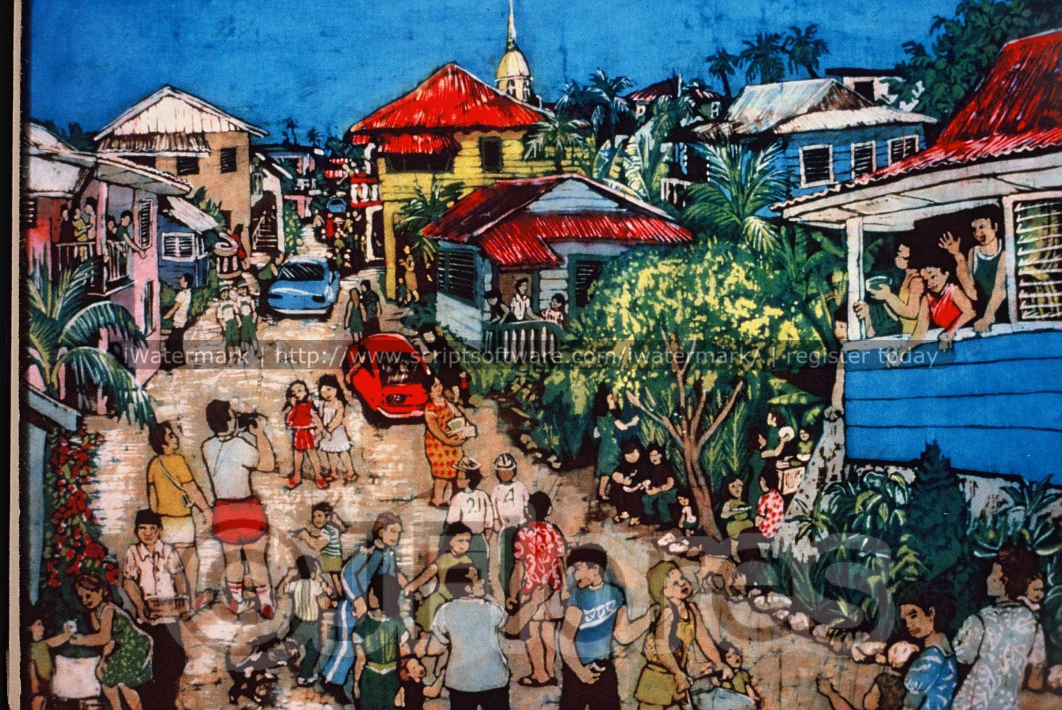
- Examine the artwork closely. How would you describe this artwork?

- What details (people, objects, activities, etc.) do you notice?

- What other information – such as time period, location, and occasion – can you gather from this artwork?

- What other questions would you ask about this artwork and where would you find the answers?

Setting the Stage
The village of Inalahan was founded in 1680 by Spanish missionaries. They designed the streets in the five-block grid pattern still existing today. They forced people to move from their clans’ lands, to live together around the church. Many were from surrounding areas and some were taken from the Mariana Islands north of Saipan, called the “Gani” people
The original structures in Inalahan began as simple thatched homes, built on poles, with bamboo floor raised above the ground about one to three meters. As time went on, some homes began to use local ifit hardwood for floors and walls. More well-to-do families added a thick rock and lime cement wall around the poles, and added massive staircases and raised terraces in the back for outside kitchen. This Spanish introduction of rock and lime mortar construction is called “manposteria.” This is the type of house that exits today in the historic district.
A visitor to Inalahan village today will be greeted in appearance by a small tightly knitted community of homes and businesses looking much like it did shortly after the wars end. Spread among the modern homes of today are homes still made of limestone, wood, and tin. Seen as a Spanish styled village by many, the homes today reflect a mixture of architecture and building materials influenced by both Spanish period rule and American rule.
Inalahan is a place of rich heritage and historical significance. In 1977 the village of Inalahan was listed in the National Register of Historic Places as a Historic District. The buildings within this district serve as great examples of the many different influences to building construction during these periods found throughout Guam. Many of the homes showcase uses of a local hard wood called ifit, now endangered and protected, to frame and floor their homes. Massive outside staircases and’ bodeggas’ a sub-level storage area used widely by the Spanish can be seen throughout the village. There are many examples of both single and multiple story homes. Many of the homes in the village are being preserved using funds provided by the federal government, under the direction and vision of the Guam Preservation Trust. These homes include the Leon Guerrero House built in 1901, the George Flores House, the Manuel L.G. San Nicolas House, and Church of St. Joseph.

Visual Evidence
Photo 1: Mariano & Ana Leon Guerrero House

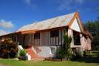
Built in 1901, the house is an excellent example of this period; with manposteria bodega; ifil flooring, frame, siding; steep metal roof and massive exterior steps
Questions for photo 1:
1. Identify some of the construction elements found on this house.
2. Unlike most homes found on Guam today this house has a pitched roof. Discuss and list several reasons why you think most of the prewar homes roofs were similar in design.
3. The shiny white wall near the stairway makes up what architectural element. Why does it appear to be so white?

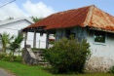
Visual Evidence
Photo 2: Manuel L.G. San Nicolas House, late 1800’s

Built in 1846, this house is probably the oldest existing house in Inarajan. The exposed ifil poles and framing make this house a good model of traditional construction method. Because of its’ deteriorating condition we are able to see the notches used to connect the roof to the poles. The house also provides us a good view of how the batten walls were constructed without the use of nails; yet secured to the framing of the house. An earlier photo shows that the original roof was made of nipa thatch.
Questions for photo 2:
1. In the photo above what materials can be seen used in the house construction?
2. Identify some of the construction elements found on the home.
3. Compare and contrast the differences between the home pictured above and the homes seen on Guam today.

Visual Evidence Photo 3:
George S.N. Flores House and Retail Store 1915
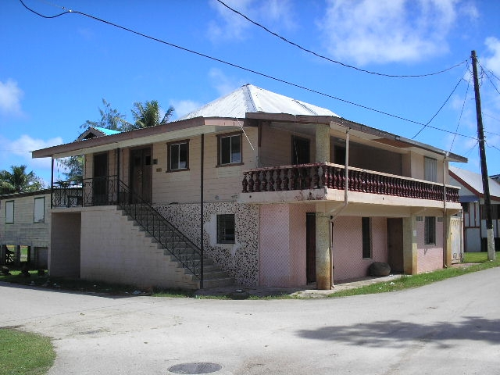
This house was built in 1915 by George’s father, Jose. This large two story house was divided so that the upstairs was used as the living quarters, while the bottom was used as a retail store. The house shows features of the remodeling that was done in the 1970’s. Currently this house now serves as the cultural museum for the village and the present day “hotno “ or Spanish oven bakery.
Questions for photo 3:
1. Identify some of the construction elements found on the home.
2. Identify and describe the differences in the materials used in the original versus the remodeled home.
3. The house behind the Flores home also shows an open first floor used in most post war homes. Can you identify this element? (hint: the bodega is an enclosed area.)
Locating the site
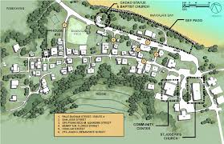
Map 2: Physical layout of homes within Inalahan village

The main road entering Inalahan village is route 4. This road is seen at the top of the photo. As you pass the ball field on the right you will see the ruins of the old Baptist church on your left along with the bronze statue depicting Chief Gadao. Further along situated on the bay side sits Ysengsong Gef Pago; a cultural center for visitors to observe and experience the traditions passed down from the past. The large building on the bottom right is St. Joseph church. Adjacent to the church is the community center and office of the mayor. Walking village painted history tours can be arranged through Gef Pago.
Questions for Map 2:
- What historical significance is seen in the placement of the church and its proximity to the Mayor’s office?
- Why do you suppose that there are no homes located on the beach shore?

Locating the site
Map 1: Inalahan, Guam
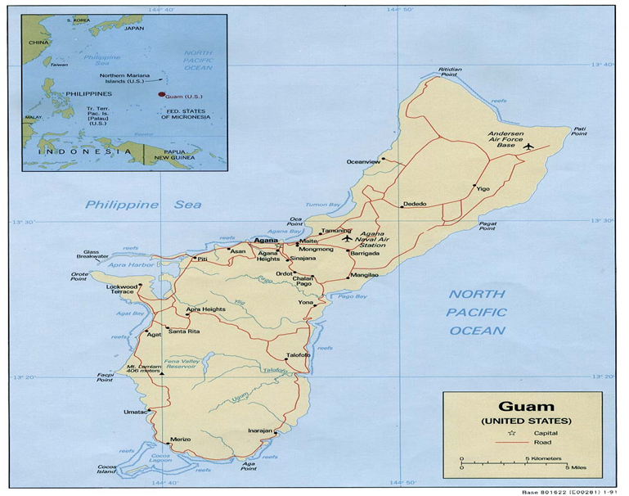

Questions for Map 1:
- Identify three countries located near Guam.
- Inalahan village along with Humatak village are both considered as historic districts. What factors do you think contributed to this selection?
- Name the three villages closest to Inalahan.

Visual Evidence
Photo 3: Ariel View of Inalahan Village

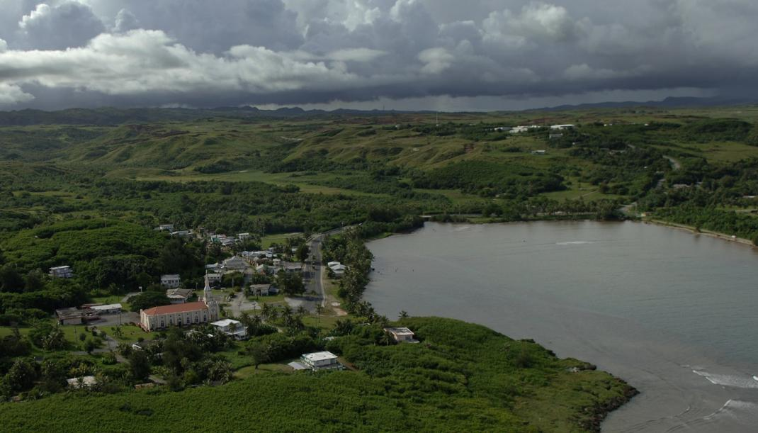
Located on the southeast coast of Guam, Inalahan village lies between a long, narrow bay and surrounded by rolling hills and mountains to the west and south. In the upper right of the photo you see the tops of the buildings that makeup Inalahan Middle School.
Questions for Photo 3:
- Looking at the picture closely, can you identify what large building dominates the village skyline?
- What topographical features contributed to this area being chosen as a perfect place to live?
- What do you think most of the original settlers of Inalahan did as a way to provide food for themselves?

Determining the Facts
Reading 1: The Legend of Gadao
Malagua’i, was a powerful chief of Tomhom, in the north of Guahan. He came to Inalahan in his canoe to challenge Gadao. Upon beaching his canoe on the bayside, he met a man whom he mistook as a servant or assistance to Gadao. The man was in fact, Gadao; but he continued to pretend to be Gadao’s assistant and invited Malagua’i to sit and eat while they awaited Gadao’s return. While they waited, Gadao began to prepare food. First, he obtained coconuts from a tree by shaking the tree instead of climbing it to pick the fruit. Next, he squeezed the cream from the coconut by twisting the unopened nut in his bare hands. Seeing this, Maliagua’i thought to himself that, if the assistant was so strong, how much stronger must the chief be; and he decided to leave. As he got into his canoe, Gadao revealed his true identity and jumped into the other end of Malagua’i’s canoe. Malagua’i paddled furiously towards the sea, and at the same time Gadao paddled in the opposite direction. The strength of the two men was such that the canoe broke in half. Malagua’i shot out to sea in his half of the canoe, while Gadao’s half cleaved into the land, creating the Inalahan River. Following this battle, Gadao wrote about the story in the cave at the mouth of Inalahan Bay. Today,this same petroglyph can be seen in Gadao’s Cave. The statue seen below can be found as you enter Inalahan, Gadao proudly paddling in his canoe.
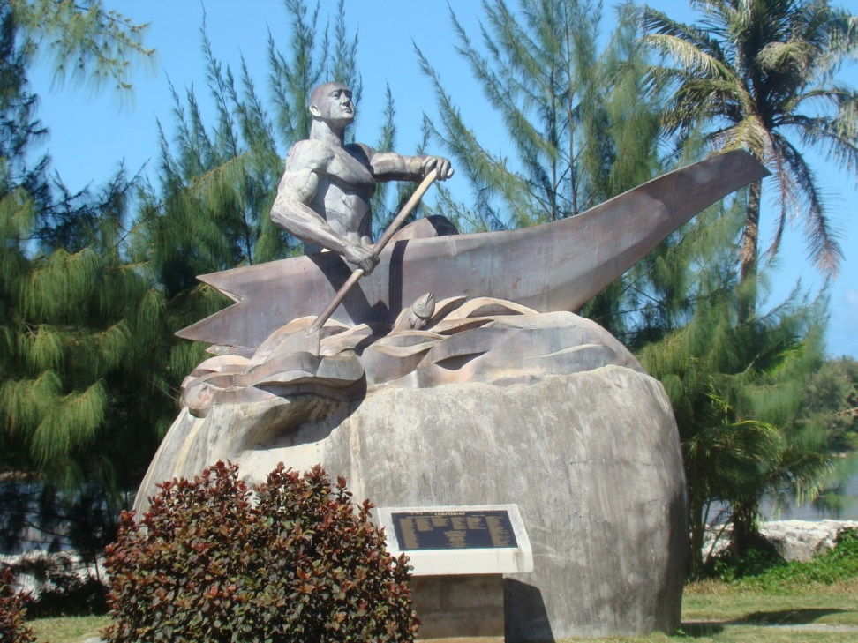

Questions for reading 1: The Legend of Gadao

- Compare the differences between the time that Chief Gadao was living in Inalahan Village and today. What are some similarities shared between the two villages.

- What human characteristics do you think are immortalized in Gadaos’ legend?

- What reasons do you think Gadao could have had for not revealing himself to the visiting Chief when they first met?

Reading 1 was excerpted from Judith Selk Flores. Estorian Inalahan:History of a Spanish–Era Village in Guam. PO Box 56 Hagatna, Guam: Irensia Publications, 2011. Pp. 2.

Determining the Facts
Reading 2: Pale’ Duenas
Father Jesus Baza Duenas (Pale’ Duenas) was a legendary person in the history of Inalahan. He was the first Chamorro priest to be ordained in Guam, and he was assigned to minister to St. Joseph parish just before the war broke out. During the Occupation years, there were only two priests left to minister to the islanders – Father Oscar Calvo ministered to the people of Hagatna and northern areas, while Father Duenas ministered to the people of the south. People fondly recall his visits to their remote ranches during the war years. He was a very striking figure in his white robe, riding a white horse. He baptized babies, blessed the sick and performed marriages in the isolated lanchos where his parishioners lived. The Japanese suspected him of being a spy and of helping to hide George Tweed, the only American military man who avoided capture during the war. They also hated him because he defied their attempts to make him stop saying mass in the church.
In July,1944, Japanese soldiers arrested and tortured Pale’ Duenas at Puntan Songsong, in front of the Jose San Nicolas home which they had taken over as command headquarters. The torturers brought village residents and those working in the rice paddies and commanded that everyone stand and watch as they beat and tortured Pale’ Duenas and his cousin, Edward Duenas. Anyone who cried out in sympathy would be killed.
After three days of torture, he was thrown into the back of a truck and taken away to Ta’i, Mangilao, along with his cousin, Juan Cruz Flores, and another Chamorro, Mr. Joaquin Limtiaco. The men managed to get loose from their bonds during the night, but Pale’ Duenas refused to escape with them, saying he was too injured to move and that he was ready to face his God. He told them that their obligation was to their families, and to leave him. Reluctantly, they left him, and he was beheaded the next morning, on July 12, 1944, less than two weeks before the American forces re-took the island. A mass for Father Duenas is held every July 12 at St. Joseph Church, celebrated by the bishop and attended by relatives and others from all over the island.
Questions for Reading 2: Pale Duenas

- Why do you suppose that the Japanese captors of Pale Duenas wanted his torture and interrogation, to be held in front of the whole village? Do you feel as though they succeeded?

- Why do you think it was important for Pale Duenas to defy the Japanese order to say mass in church?

- What feelings do you think the people of Guam had upon hearing the news of Pale Duenas’s? Do you think that his death had the reaction on the people that the Japanese had hoped for?

Reading 2 was excerpted from Judith Selk Flores. Estorian Inalahan:History of a Spanish–Era Village in Guam. PO Box 56 Hagatna, Guam: Irensia Publications, 2011. Pp. 130-131.

Determining the Facts
Reading 3: Inalahan Survivor Stories
Inalahan residents were spared from joining the concentration camp in Manenggon, near Yona, where the majority of people were forced to march from all over the island. Instead, the people were marched to two camps in the hills behind Inalahan. One camp was in a place called Atati, and a second camp was at Umoffit. A large group of over a hundred men, women and children marched from one or both of these camps through the mountains behind Inalahan to Malesso, to what they thought was a safer place.
Juan N. Flores, who was 8 years old at the time, told of his family members taking turns carrying his great grandmother, Nan Checha, (Theresa Torres Duenas) in a hammock made from a blanket. She was close to 100 years old at the time. After carrying her far into the mountains, members were no longer able to carry her any further. So they left her at a small shelter with water and what little food they could spare. They weren’t able to return for more than two weeks, at which time they found her still alive. She said that a Japanese soldier had come, but when he saw that she was alone and without food, he left without harming her. Meanwhile, the rest of the group continued over the mountains until they reached the Merlin G. Cook School in Malesso. There were so many people that they couldn’t all fit inside the school. Some of them, therefore, hid under the building.
Suddenly, the school was surrounded by several Japanese soldiers, who shot into the school killing some of the people. One soldier threw a live grenade towards the open door. One man quickly shut the door, causing the grenade to bounce back and kill several Japanese. The group managed to overcome the soldiers, using whatever weapons they had. They eventually were escorted back to Inalajan when authorities felt the area was safe

Questions for reading 3: Inalahan Survivor Stories

- Why did the villagers of Inalahan think that it was safer to be in Malesso? What have we learned in Guam history that shows they were mistaken?

- Imagine that you were the grandmother. Describe the feelings you felt when you realized that they were going to leave you alone at the ranch. Other than the food they left with you; what other types of food would you have been able to eat.

- What belongings do you think the people in the story took with them as they were forced to leave their homes? What would you have grabbed if could only take what you can carry.

Reading 3 was excerpted from Judith Selk Flores. Estorian Inalahan:History of a Spanish–Era Village in Guam. PO Box 56 Hagatna, Guam: Irensia Publications, 2011. Pp. 134-135.

Determining the Facts
Reading 4: Farming is Happy Work
Mr. Rivera was raised in Inarajan village, but now lives in Malojloj. As a young boy, he used to pick firewood and pasture cows before he left for school and again when he returned from school. In school, gardening was part of their school work and they did all of their farming by hand. They grew cherry tomatoes, cabbages, eggplants, and bell peppers. In their garden, no fertilizers or insecticides were needed because the soil was very fertile. Before the war, Mr. Rivera remembers corn as being their main food. On his farm, he now grows wing beans, bell peppers, tomatoes, eggplants, okras and wild cherry tomatoes.

Mr. Rivera has been a farmer all his life. He said, “A long time ago it was hard to farm, nowadays you have to spend a lot of money to kill insects and to make plants grow easily.” He starts farming at five o’clock in the morning and stops at ten o’clock in the morning to rest, because it gets so hot. He starts again at five o’clock in the afternoon and works until seven o’clock in the evening. He spends about six hours a day farming. Mr. Rivera enjoys farming because farming is interesting and challenging work, and makes him happy to see his plants grow according to Mathew Quintanilla who interviewed Mr. Rivera.

Questions for reading 4: Farming is Happy Work
- Why do you think farming was so important for Mr. Rivera?
- What sort of tools did Mr. Rivera use to farm?
- Compare and contrast farming back then and now.

ACTIVITIES THAT HELP PUT IT ALL TOGETHER
The following activities will help the students to understand and appreciate the uniqueness of Inalahan Village along with its rich history.
Activity 1: Inalahan Village through Time
Have students create a timeline of the significant events and changes that occurred within Inalahan Village. They can show different activities that people of the village did; or how the structures of the village change through time. They can take photographs of structures that show these influences in construction or use. The students can make a depiction of what they thought the village may have looked like in an earlier time before photographs or what changes they would add to the village now.
Activity 2: Inalahan VillageThrough Images
Have students create a collage of various sites and scenes from Inalahan. These may include pictures of the different homes found throughout the village; Chief Gadao’s statue, different ruins and remnants significant to the villages’ history, and artifacts found around the village. Maybe they could include scenes of different activities conducted within the village and Gef Pago. Afterwards they could possibly share these images with their peers through a presentation.
Activity 3: Inalahan through Drawing
Have students create a map and label the various structures found throughout the village. They can draw scenes from Inalahan that they observed during the walking tour. They can create their own scenes or pictures that they would add to the “Painted History Walk” found on buildings within the village.

Supplementary Resources
Critical Past
With more than 57,000 historic clips and 7 million stills for immediate download, www.criticalpast.com is a source for imagery of worldwide events, people, and B-roll spanning the 20th century. Drawn largely from U.S. government sources, the site contains a vast collection of vintage military and war footage, as well as 20th century propaganda and educational films from many countries. The Critical Past war collection includes footage from World War I, World War II, The Korean War, The Vietnam War, and The Cold War.
Estorian Inalahan
A book written by Judith Selk Flores and published by Irensia Publications. It describes the rich history and heritage of Inalahan Village. It chronicles the periods that have contributed to Inalahans’ unique character through the ages; starting with the Latte Period and making its way through the Spanish Colonial Period, the American Colonial Period, World War II- the Japanese Occupation, to the Inalahan Village we enjoy today.
Guampedia Foundation, Inc.
Guampedia is Guam’s online encyclopedia that was created as a community project in order to provide a resource on Guam history, Chamorro culture and people. Its website is www.guampedia.com and in it you will find many useful resources on the topics of art, environment, government, history, society, and villages related to the island of Guam.
Guam Preservation Trust
The Guam Preservation Trust (GPT) was created in 1990 as a non-profit, public corporation governed by a Board of Directors. It is dedicated to preserving Guam’s historic sites and culture, as well as educating the public about these issues. Their website www.guampreservationtrust.org includes photos of historic structures both pre and post war Guam.
The History Channel
Its website on www.history.com allows access to articles, videos, and speeches related to various topics of WWII both on Guam and around the world.
Micronesian Area Research Center (MARC)
MARC located at the University of Guam seeks to acquire, preserve and provide access to collections of archival maps, photographs, texts and cultural materials. Their website, www.uog.edu/micronesian-area-research-center/marc-home , hosts much of their collections and they continue to expand and dedicate staff time to digital resources.
National Park Service
The War in the Pacific National Historical Park provides detailed resources about World War II in Guam. Their website, www.nps.gov/wapa, showcases WWII photos and multimedia. It also provides links to pages, digital books, and articles (sponsored by the National Park Service) relating to the battles across the Pacific Theater, including Guam. There are also digital brochures and literature that can be downloaded to learn about the events that led to the outbreak of the Pacific War, the Battle of Guam, and the role the Mariana Islands played in helping to end WWII.

