The Unique and Varied History of Asan Beach

Introduction

Asan Beach Park has become a popular place for many people: picnickers, exercise enthusiasts, and kite flyers. This calm and peaceful beach was not always like this. Seventy-one years ago, it was the sight of one of the major battles during World War II.
On the morning of July 21, 1944, thousands of U.S. Marines came ashore and battled against the Japanese forces that controlled the caves, machine-gun nests, and artillery bunkers. The U.S. Marines fought hard to secure this narrow strip of beach, and once it was secured, the Americans used it as a staging area for assaults on Japanese strongholds at other parts of the island. The events eventually led to the Americans victory over the Japanese forces on Guam.
Asan Beach today is one of seven park units on Guam that commemorates the people who fought, died, and survived here on Guam during World War II. It is a War in the Pacific National Historical Park established since August 18, 1978 “to commemorate the bravery and sacrifice of those who participated in the campaigns of the Pacific Theater of World War II and to interpret and preserve the outstanding natural, scenic, and historic values and objects on the island of Guam”.
Besides being a battlefield and U.S. landing site, did you know that Asan Beach was also the site of a Leper Colony, prison camp, hospital annex and refugee camp? This lesson will explore the rich history of Asan Beach Park from pre-World War II to present.

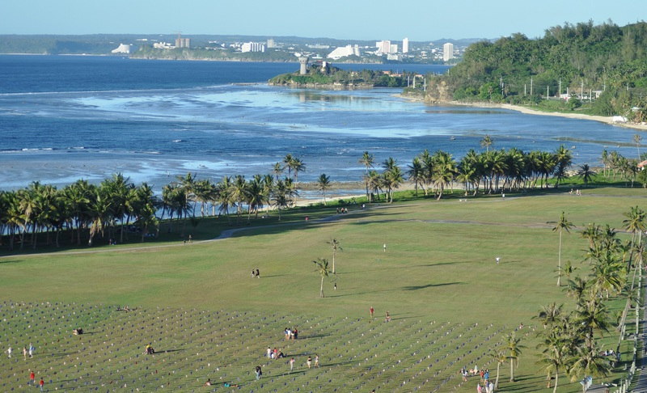
(Photo taken from http://www.beach-on-map.com/asan.html)
General Citation

About this lesson
This lesson is based on the National Register of Historic Places registration file, “Asan Beach Park” with photographs and other source materials. This lesson was written by Michele Arriola, a teacher with Guam Department of Education. This lesson is one in a series that brings the important stories of historic places into the classrooms across the country.

Where it fits into the curriculum
Topics: This lesson can be used in American History, social studies, and geography courses in units on World War II.

Time period: Mid 20th Century

Relevant United States History Standards for Grades 5-12
Era 8: The Great Depression and World War II (1929-1945)
Standard 3A - The student understands the international background of World War II
Standard 3B - The student understands World War II and how the Allies prevailed
Standard 3C - The student understands the effects of World War II at home

National Council for the Social Studies (NCSS) Standards
Theme I: Culture
Standard B - Students give examples of how experiences may be interpreted differently by people from diverse cultural perspectives and frames of reference
Theme II: Time, Continuity, & Change
Standard A - Students demonstrate an understanding that different people may describe the same event or situation in diverse ways, citing reasons for differences in views
Standard D - Students identify and use various sources for reconstructing the past, such as documents, letters, diaries, maps, textbooks, photos, and others

Theme III: People, Places & Environments
Standard B - Students interpret, use and distinguish various representations of the each, such as maps, globes, and photographs
Standard E - Students locate and distinguish among various landforms and geographic features, such as mountains, plateaus, islands, and oceans
Standard H - Students examine the interaction of human beings and their physical environment, the use of land, building of cities, and ecosystem changes in selected locales and regions
Theme IV: Individual Development & Identity
Standard B - Students describe personal connections to place - especially place as associated with immediate surroundings
Theme V: Individuals, Groups, & Institutions
Standard E - Students identify and describe examples of tensions between individual’s beliefs and government policies and laws
Theme VI: Power, Authority, & Governance
Standard F - Students identify and describe factors that contribute to cooperation and cause disputes within and among groups and nations
Theme IX: Global Connections
Standard F - Students investigate concerns, issues, standards, and conflicts related to universal human rights, such as the treatment of children, religious groups, and effects of war.

Guam Department of Education (GDOE) Standards for Social Studies
Grade 6: History
Standard 6.2.2 Construct and interpret time lines of events and civilizations studied.
Grade 7 : World Geography
Standard 7.3.1: Interpret maps, globes, satellite images, photographs or diagrams
Grade 8 : U.S. History from Reconstruction to Present
Standard 8.2.9 Identify the major causes and effects of American Involvement in World War II
High School: Guam History
Standard GH.2.3: Identify and describe historical periods and patterns of change during the eras of Guam History, including the Japanese occupation
High School: U.S. History from Ancient Times to Present
Standard US2.13: Examine the events of World War II
Standard US2.14: Describe the effects of World War II on the home front
High School: World Geography
Standard WG.2.1: Apply and synthesize key concepts, such as chronology, change, conflict, and complexity
Standard WG3.1: Analyze maps, globes, satellite images, photographs, or diagrams
High School: World History from Ancient Times to Present
Standard WH.2.26: Assess the worldwide impact of World War II

Objectives for students

- To explain the historical significance of Asan Beach in the Battle of Guam during World War II and the outcome of the war.
- To determine why Asan Beach was an ideal landing site and the challenges the Americans faced during World War II.
- To outline and explain all the, significant historical events that took place at Asan Beach from pre-World War II to present.
4. To collaborate with group members to design a monument and plan a History Fair to further educate their peers on the rich and unique history of Asan Beach Park.

Materials for Students
The readings, maps, and photographs outlined below can be viewed through the computer or photocopies of a print out distributed to students.
- Three Readings: Each of the three readings emphasize a historical significance of Asan Beach . Reading 1 outlines the events that took place at Asan Beach during World War II. Reading 2 examines the advantages and disadvantages of Asan Beach as a landing site during World War II. Reading 3 explores other, historical events that took place at Asan Beach Park from pre-World War II to present.
2. Two Maps: Map 1 is an satellite, aerial view of Asan Beach. Map 2 is the map of Guam with a distance key.
3. Five Visual Evidence Photos: The first photo shows the beachhead of Asan during World War II. The second photo shows the destruction of Asan Beach after World War II. The third photo shows the invasion map used by the Americans. The fourth photo shows relics at Asan Beach that are silent reminders of the war and Japanese occupation Guam. The fifth photo shows Camp Asan, which was once located at Asan Beach Park.

Visiting the Park
The War in the Pacific National Historical Park has seven National Park Service sites located throughout Guam. They are Asan Beach, Asan Overlook, Piti Guns, Mt. Tenjo/Mt. Chachao, Apaca Point, Mount Alifan, and Fonte Plateau. For arranged tours with a park ranger, you may contact the T.Stell Newman Visitor Center. It is open daily from 9:00 A.M. to 4:30 P.M., except on Thanksgiving, Christmas, and New Year’s Days. The information desk can be contacted at (671) 333-4050.

Teaching Activities

Getting Started

Inquiry Question

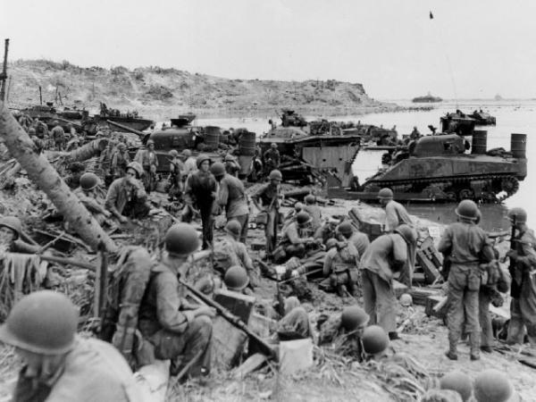
(Courtesy of National Park Service)

- How would you describe the photo?

- What details (people, objects, activities, etc.) do you notice?

3. Where do you think this photo was taken at?

3. What questions do you have about the photo? How might you find answers to these questions?

Setting the Stage

Just four hours after the bombing of Pearl Harbor in Honolulu, Hawaii, nine Japanese warplanes flew over the island of Guam in formation of threes bombing the villages of Sumay, Piti, and Hagatna, and other populated areas of the island. It was December 8, 1941, the feast of the Immaculate Conception and any residents were in Hagatna for the annual procession. The people of Guam were terrified and scrambled for safety and protection from the air attacks. Guam was drawn into World War II.

Three months after the initial invasion, some 14,000 Japanese army and navy forces took over all government and church buildings, seized many private homes, and turned the island into a military camp. Guam was now under the complete control of Japanese rule, and would remain so for the next two and a half years. It was a time of hardship and suffering for Guam’s residents and this resulted in the deaths of 1,170 Chamorros, with another 14,721 suffering the atrocities of war.

On July 21, 1944, the American invasion forces began landing at Asan Beach and Agat Beach. The full liberation of Guam took three weeks, with 1,800 U.S. Servicemen killed and a total of 7,400 casualties, plus another 17,500 casualties for the Japanese forces.

Asan Beach has a rich history. Not only did it play a major role as a landing site and battlefield during World War II, but it was also the site for a leper colony, prison camp, Navy headquarters and barracks, small military base, hospital annex and Vietnamese refugee camp. Asan Beach is a protected park today by the War in the Pacific National Historical Parks. Asan Beach’s unique and varied history, must be preserved and passed on for future generations. If it is not passed on, it will soon be forgotten.

Note: Asan Beach is also referred to as Asan Beach Park or Asan Point.

Locating the Site

Map 1: Aerial Map of Asan Beach
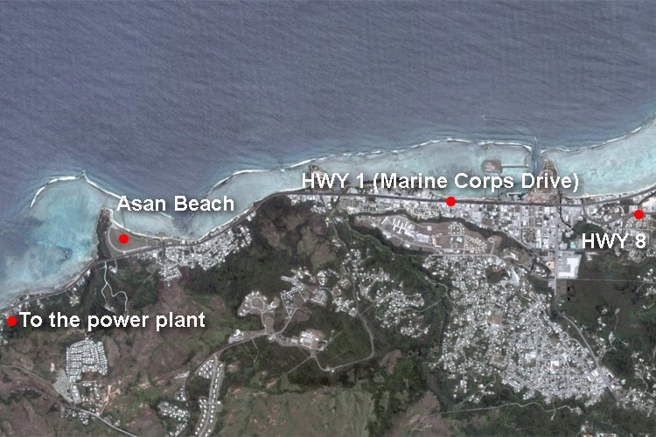
(Courtesy of Google Maps)

- According to the map, along which road can Asan Beach be found? What is the name of the road?

- What do you think the blue, green and white areas on the map represent?

- What section of the map looks more populated? Which area might that be?

- What other information can you gather from the map (terrain, waterways, elevation)?

Map 2: Map of Guam

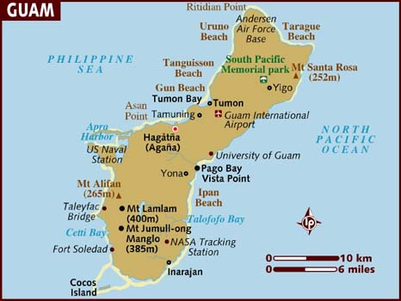

- Locate and draw a circle around Asan Point on the map of Guam.

- Is Asan Point located on the northern, central or southern part of the island?

- About how many miles from Hagatna is Asan Point?

4. What body of water borders Asan Point?

Determining the Facts

Reading 1: Asan Point’s Important Role in the Recapture of Guam

In 1931 the Navy was ordered to have the island demilitarized. Before WWII Congress determined that due in part to its remote location, Guam was indefensible. Strategically, Guam held little importance to the United States. In October of 1941 the 18th Air Unit of the Japanese Navy started flying reconnaissance missions over Guam. On Dec 4, 1941 the 144th Infantry Division known as the South Seas Detachment of the Japanese Army picked up the 5th Defense Force in Rota and headed to Guam. On Dec. 8 & 9, the 18th Air Unit bombed Guam. On Dec. 10, 1941, a gallant but futile stand was put up by US Marines and members of the Insular Force Guard of Guam. The small garrison of US and Chamorro military personnel was no match for the massive invasion force. The island was surrendered to the Japanese. The intent was to cut off the U.S. from the Philippines and to use Guam as an alternate airfield. However, the primary objective for occupying Guam was for the Japanese to protect the vital sea route. During the Japanese occupation, the Chamorro population suffered from work camps which demanded that they repair airfields, built and paved roads, dug hillside caves, trenches and tank traps. The Chamorros were forced to learn and speak Japanese, grow food for Japanese soldiers, and built structures such as tank barriers, pillboxes and gun emplacements.
In June of 1944, the United States Armed Forces were ready to retake the island of Guam. The Japanese also knew of this plan. Most of the permanent and elaborate defense installations were placed at Tumon Bay. On June 16, 1944 US cruisers, battleships, and aircraft bombed and shelled Asan and Agat beaches. The Japanese now knew where they planned to attack. The US attack was supposed to take place on June 18, 1944 but was delayed because of the battle for Saipan and the naval battle of the Philippine Sea, known as the Marianas Turkey Shoot. The new invasion date was scheduled for July 21, 1944. This decision also allowed preparation for an Army division to be part of the invasion. Japanese defensive positions were placed on top and on both sides of Asan and Adelup Points. But the previous defenses in Tumon Bay were left because there was not time to move them. The fortifications of Japanese beach defenses were extensive.
Obstacles and mines were placed on the fringing reef. The beaches and immediately inland were filled with obstacles and tank traps. Further inland were machine gun positions, pillboxes, heavy weapons, artillery and coastal defense guns. And higher inland to shoot down on the beaches were machine guns, heavy weapons, and artillery.
The code name for the Guam operation was "Stevedore". United States Navy support included 4 battleships, 3 cruisers, and 3 destroyers just off of Asan. Underwater Demolition Teams came in to destroy obstacles before the US Marines landed. There were 12 troop transports containing the 3rd Marine Division and 16 Landing Ships Tank. The bombardment of the island began at 0530 am on July 21, 1944. Over 18,000 various sized shells were expended and nine thousand rockets launched over the island. Then at 7 am on July 21, the LST's moved toward shore in Asan to unload 180 armored landing vehicles full of assault troops. The Japanese had perfect observation and firing points from high ground. But the mission included securing those high positions to make the beachhead secure for US Marines and Army soldiers to live, sleep, eat, and stockpile supplies.
The lead elements of the 3rd Marine Division crossed the reef from 200 to 500 yards offshore and landed on Asan Beach, which was defended by the Japanese 320th Independent Infantry Battalion and naval troops manning the coastal defense guns. The plan was to fight between Adelup and Asan Points, referred to as "the devil's horns". From east to west, two battalions of the 3rd US Marine Regiment landed on Beach Red 1, one battalion of the 3rd US Marine Regiment landed on Beach Red 2, three battalions of the 21st US Marines came ashore on Beach Green, in the middle, and three battalions of the 9th US Marines landed on Beach Blue adjacent to Asan Point.
The 3rd Marine Division operation order called for the three regiments to land abreast, capture the high ground immediately inland, and prepare for further operations to the east and southeast. Marines assaulted beaches, took Orote Peninsula, and the land behind Asan and the Force Beachhead Line from Adelup Point to Mt. Chachao/Mt. Tenjo. The Army's 77th Infantry Division fought in Agat, and took Mt. Alifan and the Force Beachhead Line from Facpi Point to Mt. Tenjo. The Asan area was secured on July 28th, but it took until August 10, 1941 to eliminate all organized resistance on the rest of Guam.
About 55,000 young Marines and Army soldiers participated in the battle for Guam. 1,866 American servicemen were killed in action or died of wounds during twenty one days of combat. Because of their sacrifice we now enjoy freedom on Guam today.

Reading 1 Questions:
- Why did the Japanese invade Guam?
2. Were the Japanese aware of the Americans’ plan to retake Guam? How did the Japanese know where the Americans planned to attack?
3. What date did the American land at Asan Beach to recapture Guam? Why is that date important to Guamanians today?
4. What type of planning is involved in deciding to go to war?
5. What military activities were used to secure Asan Beach?
6. Who won the war? How long did the war last on Guam?
7. How many U.S. soldiers participated in the battle for Guam?
8. How many Americans were killed in the Battle of Guam?
Reading 1 was excerpted from United States. National Park Service. “Asan Beach Unit”Web. 27 July 2015. <http://www.nps.gov/wapa/planyourvisit/asan-beach-unit.htm>
Determining the Facts
Reading 2: Why Asan Beach Was Chosen as a Landing Site?

By 1944 the tide of war had turned firmly against the Japanese. The U.S. and Allied forces steadily pushed the Japanese military back at all points across the Pacific. To counter this onslaught the Japanese high command reinforced Japanese held islands to create a defensive ring around the Japanese home islands.
Late in the war the Japanese Army's 29th Division, under the command of LtGen Takeshi Takashina, was assigned to protect Guam. To command his defense of the island, LtGen Takashina located the main Japanese command post in a dugout atop Fonte Hill. Fonte Hill overlooked Asan Beach on the north coast of Guam. From this central location, LtGen Takashina commanded his troops and issued orders to all Japanese military units on the island. LtGen Takashina had roughly 18,500 men to defend the island.2
In preparation for the anticipated American assault on Guam, the Japanese constructed fortified defensive positions using large caliber artillery on the hills and mountains overlooking the most likely landing beaches. This preparation allowed preregistered artillery and mortar fire to rain down on any American attackers as they debarked their landing craft, turning the beaches into a well-prepared killing ground.
The U.S. military chose 21 July 1944 to invade Guam. Asan Beach was selected for the main landing because of its size and suitability to support a large-scale amphibious assault. The mission of establishing the initial beachhead fell to the 3d Marine Division, roughly 17,000 men strong, comprised of the 3d Marine Regiment, the 21st Marine Regiment, and the 9th Marine Regiment.3
Just beyond the beach an open area, consisting mostly of rice paddies, extended approximately 1,200 yards inland. Past the rice paddies, a ring of foothills rose steeply and formed a semicircular mountain range-thus encircling the entire Asan beachhead. The beachhead resembled a huge amphitheater with the Japanese commanding the high ground of the surrounding foothills and mountains, and the Marines occupying the low ground open on all sides to Japanese fire and possible counterattack.
The mission of the three assault regiments was to get ashore, get across the rice paddies and low ground, and establish positions in the foothills. During his preinvasion briefing to his subordinates, one Marine commander put it, "The theory is simple gentlemen. It's the old school solution-seize the high ground and hold it."4
After establishing a foothold on the island, the assault regiments held a small perimeter while subsequent waves of Marines were brought in to reinforce and expand the beachhead. Once the first Marines landed, artillery and mortar fire from the Japanese defenders accelerated. As one Marine commander recalled:
As the Marines clawed their painful way up the high ground commanding the beachhead, there was nothing to do but accept the incoming Japanese mortar and artillery fire.5
The opposition started light on the beaches but increased steadily as the troops moved inland to high ground.6
The 3d Marine Division found itself in a tenuous situation at the end of the first day. The Marines had secured a foothold on the Asan beachhead, but the Japanese still held the surrounding high ground. With excellent visibility from the mountains, the Japanese could identify virtually every Marine position and any equipment on the beach. After the battle, once this high ground had been captured, the commanding officer of the 9th Marine Regiment wrote:
Three huge telescopes of 20 power were found. Looking through these scopes one could almost make out individual features of Marines below us. Practically every part of our lines and rear areas, as well as my own Command Post, could be seen through these glasses from this high ground.7
From such an advantageous position the Japanese inflicted heavy casualties among the invaders.
Two days after the 3d Marine Division landed, LtGen Takashina gathered his staff for a meeting. Unable to dislodge the Marines from their foothold on the beachhead, LtGen Takashina solicited recommendations from his staff on various courses of action. After conferring with his staff, LtGen Takashina chose to gather all Japanese units possible and launch a general counterattack on the night of 25-26 July and drive the invaders back into the sea.8
At dawn on 25 July 1944, the battle for the Asan beachhead by the 3d Marine Division began its fifth consecutive day. During the first 4 days on the island, the 3d Marine Division encountered extremely stiff resistance on the left flank of the beachhead, directly in front of Fonte Hill.

Questions for Reading 2

- Where was the Japanese Command Post located?

2. Why was Asan Beach selected as a landing site for the U.S. Marines?

3. Explain how the geographical feature around Asan Beach was advantageous to the Japanese and challenging for the Americans.

- How long did it take to secure the Asan beachhead?

- What types of hardships do you think both American and Japanese soldiers had to endure?

Reading 2 was excerpted from Kiehle, Mark A. “Battle of Fonte Hill, Guam, 25-26 July 1944” Marine Corps Association & Foundation. Marine Corps Gazette, July 2003. Web. 28 July 2003. https://www.mca-marines.org/gazette/battle-fonte-hill-guam-25-26-july-1944

Determining the Facts
Reading 3: The Rich History of Asan Beach
The village of Asan was predominantly a fishing village in pre-Spanish times that switched to farming with the settlement of the Spaniards. Villages grew taro, rice and sugar cane on the fertile flatland between the beach and the hills.
In 1892, Asan beach was the site of a Leper Colony, which was used for eight years until destroyed by a typhoon. Then in 1901 the area was turned into a prison camp for exiled Filipino insurrectionists, including Apolonario Mabini, a leader against the US takeover of the Philippines, who is today considered a Philippine national hero.
In 1917, when the US declared war on Germany, the enlisted men of the German cruiser SMS Cormoran, which had been docked in Apra Harbor for three years, were imprisoned at Asan Point by the naval authorities.
In 1922, Asan Point became a US Marine Corps camp with a quartermaster depot, a small arms range, and barracks, but the area, along with most of the island, was demilitarized in 1931.
During World War II, Asan Beach played a vital part in the American recapture of Guam from the occupying Japanese forces. On July 21, 1944, the American invasion took place on the beaches of Asan and Agat, beginning with a bombardment of the island at 5:30 a.m. Japanese defensive positions were placed on top and on both sides of Asan and Adelup points. The United States Armed Forces had four battleships, three cruisers, and three destroyers just off of Asan.
Then at 7 a.m. transports moved toward shore in Asan to unload 180 armored landing vehicles full of assault troops. Lead Marines crossed the reef from 200-500 yards offshore and landed on Asan beach, which was defended by Japanese infantry and naval troops manning coastal defense guns.
Nine Marine battalions landed at four points along the coast, assaulted the beaches, took Orote Peninsula, the land behind Asan and Libugon Hill (which was renamed after Nimitz following the war). Fighting lasted several days, with desperate Japanese soldiers making last-ditch “banzai” suicide charges at the Marines. The Asan area was secured on July 28 but it took until August 10, 1944 to eliminate all organized resistance on the rest of Guam.
After World War II ended, Asan Beach became known as Camp Asan until 1947. Camp Asan was used as headquarters and barracks for the US Navy Seabees who helped to reconstruct the island. The village of Asan was relocated further inland along the bottom of the hillside. Maina was also added as part of the municipality.
From 1948-1967 Camp Asan became the “Civil Service Camp.” In essence, it was a small military base with housing, an outdoor theater, tennis courts and a fire station. In 1968 the Navy converted the buildings into a hospital annex for use during the Vietnam War. This was utilized for seven years until the area was turned into Vietnamese Refugee Camp in 1975. There were a total of 111,000 Vietnamese refugees who came through Guam after the Fall of Saigon.
In 1976 Supertyphoon Pamela destroyed all of the remaining buildings at Asan beach and the area was cleared of the debris by the Navy. The National Park Service acquired the area in 1978 and the War in the Pacific National Historical Park was established.
Reading 3 Questions:
- Name the different uses of Asan Beach before and after World War II.

- What geographical feature(s)of Asan Beach allow for a multi-purpose use?
3. Of all the prior uses of Asan Beach, which one do you think is the most significant? Why?

4. Why do you think since 1978 Asan Beach remained an open, grassy field with no major development, like a new hotel or mall?

Reading 3 excerpted from Leo Babauta. “Asan-Maina (Assan-Ma’ina).” Guampedia. Web. 27 July 2015.

Visual Evidence
Photo 1: Asan Beach Landing Site
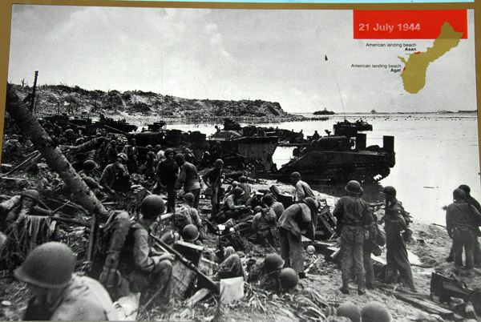
(Courtesy of National Park Service)
Questions for Photo 1
- Why do you think Asan Beach was chosen by the Americans as a landing site?
- What is the significance of the date seen at the top corner of the picture?
- What do the two red shadings on the map of Guam at top corner tell you?
4. What details do you notice in the picture?
Visual Evidence
Photo 2: The Destruction of Asan Beach

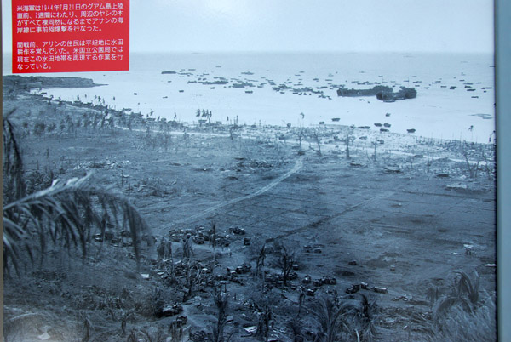

Questions for Photo 2:
- What are some of the details you notice in this photo?
2. Why does it look smokey in the picture?
3. What is your reaction to this picture? What feelings come up for you?
4. What advantage do the Japanese forces have from on top of this mountain looking down toward the Americans landing at Asan Beach?
5. What hardships do you think the Americans had to endure to reach the Japanese artillery forces and command on top of the mountain?

Visual Evidence
Photo 3: Invasion Map
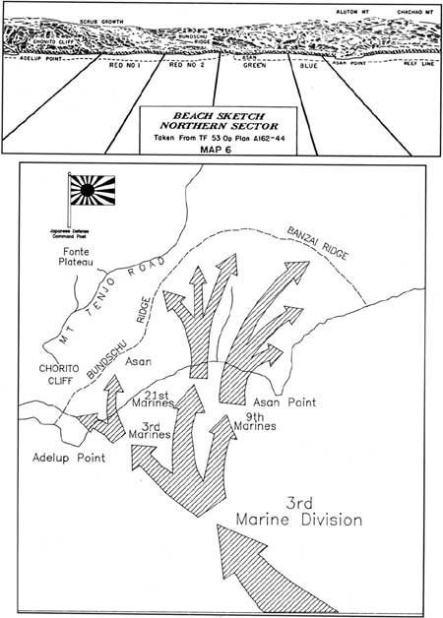
Photo 3 Questions:

- What do you think the arrows represent in the picture?

2. In which direction are the 3rd, 21st, and 9th Marines supposed to head toward after landing at Asan Beach?

3. Whose flag do you think is represented in the picture? What might this area be?

4. Is the Japanese Command Post on top of a mountain or down at beach level?

5. Why is a high elevation for a command post advantageous?

Visual Evidence
Photo 4: Relics that can be seen at Asan Beach
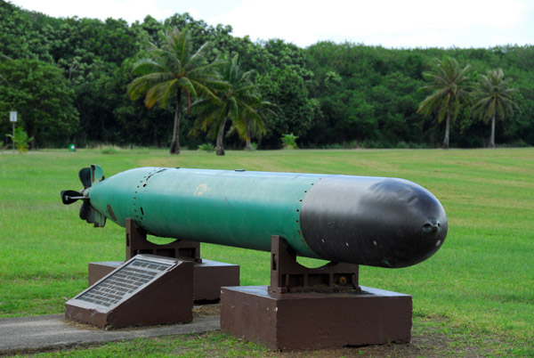
American Mark 14 Torpedo, Asan Beach, Guam
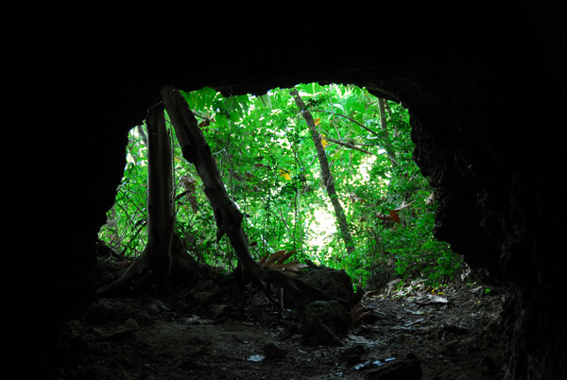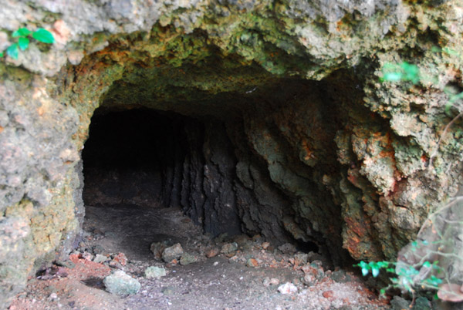
Japanese caves dug into hill on side of Asan Beach

Questions for Photo 4:
1. What is a torpedo? What is it used for?
2. What do you think the Japanese used the caves for?
3. Who do you think dug the caves?

Visual Evidence
Photo 5: Camp Asan
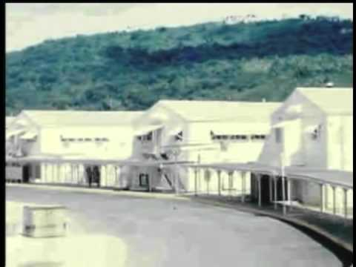
(Courtesy of Joint Region Marianas)
Questions for Photo 5:
- What details in the background remind you of Asan Beach Park?
- What could these buildings be used for?
- Who do you think lived in them?
- Why would Asan Beach Park be an ideal site for housing numerous people and other large scale activities?

Putting it All Together
The following activities will help demonstrate to students the significance of Asan Beach in the Battle of Guam and at other times before and after World War II. Activities are designed to be engaging, meaningful and hands-on.
Activity 1: Visit the Site
Arrange a field trip to Asan Beach Park to observe the environment, geographical features, relics, and monuments. Students will analyze the terrain at the beach, field and ridge points and then discuss the advantages and challenges/hardships the Americans faced in the Battle of Guam during World War II. Students will also envision the different uses of Asan Beach Park before and after World War II and then go on a scavenger hunt to find, each relic, monument, and marker at the park and jot down important notes about them, both of which will be helpful to them later when they do Activities 2 and 3.
Activity 2: Design a Memorial
Divided into groups of 4-5 students per group, students will design a memorial that will draw increased attention to the significance of Asan Beach as a landing site by the Americans during World War II . Students will do further research to ensure their historical facts are accurate and then use as much symbolism as possible in their design. The date, time, and U.S. troops’ movement through the beach on July 21, 1944 can be incorporated into their design to make it more meaningful. Students will also create a sign that will stand next to their memorial to explain the symbols used in their design. Students are encouraged to be creative. When project is completed, students will present their designs to the class.
Activity 2: Plan a History Fair
Divided into groups of 4-5 students per group, students will plan a History Fair on paper that could potentially take place at Asan Beach Park on “Guam History Day.” After constructing a time line of the various, significant historical events that took place at Asan Beach Park, each group will pick one major, historical event from pre-World War II to the present and conduct in-depth research on. They will present their research in a brochure and will also design their booth and topic-relevant hands-on learning activities and/or games. Topic-relevant food and entertainment should also be included. Some topic-relevant activities are: 1) for the World War II booth, one could dress up as a Marine and carry a 50 pound back while crawling and climbing through an obstacle course. Also, foods soldiers ate during the war can be on display. 2) In the rice paddy field booth, rice-ingredient desserts could be sold to highlight the rice paddy era at Asan Beach. Students are encouraged to be creative, but still be guided by research and topic relevancy. At the end, they will present to the class their brochure and their history fair ideas in the form of a power point presentation or display boards.
Supplementary Resources
Critical Past: With more than 57,000 historic clips and 7 million stills for immediate download, www.criticalpast.com is a source for imagery of worldwide events, people, and B-roll spanning the 20th century. Drawn largely from U.S. government sources, the site contains a vast collection of vintage military and war footage, as well as 20th century propaganda and educational films from many countries. The CriticalPast war collection includes footage from World War I, World War II, The Korean War, The Vietnam War, and The Cold War.
Guampedia Foundation, Inc.
Guampedia is Guam’s online encyclopedia that was created as a community project in order to provide a resource on Guam history, Chamorro culture and people. Its website is www.guampedia.com and in it you will find many useful resources on the topics of art, environment, government, history, society, and villages related to the island of Guam.
Guam Preservation Trust
The Guam Preservation Trust (GPT) was created in 1990 as a non-profit, public corporation governed by a Board of Directors. It is dedicated to preserving Guam’s historic sites and culture, as well as educating the public about these issues. Their website www.guampreservationtrust.org includes photos of historic structures both pre and post war Guam.
The History Channel
Its website on www.history.com allows access to articles, videos, and speeches related to various topics of WWII both on Guam and around the world.
Micronesian Area Research Center (MARC)
MARC located at the University of Guam seeks to acquire, preserve, and provide access to collections of archival maps, photographs, texts and cultural materials. Their website, www.uog.edu/micronesian-area-research-center/marc-home, hosts much of their collections and they continue to expand and dedicate staff time to digital resources.
National Park Service
The War in the Pacific Historical Park provides detailed resources about World War II in Guam. Their website, www.nps.gov/wapa , showcases WWII photos and multimedia. It also provides links to pages, digital books, and articles (sponsored by the National Park Service) relating to the battles across the Pacific Theater, including Guam. There are also digital brochures and literature that can be downloaded to learn about the events that led to the outbreak of the Pacific War, the Battle of Guam, and the role the Mariana Islands played in helping to end WWII.

