Manenggon: Death March
Introduction
Guam’s southern villages live up to the old adage of “Southern Hospitality” for most people who reside on this little island in the Pacific Ocean. Driving down south, one can quickly notice the slower paced lifestyle compared to the hustle and bustle of most northern villages. Located on the eastern coastline of the island, the first southern village leading to the southern part of Guam is the village of Yona.
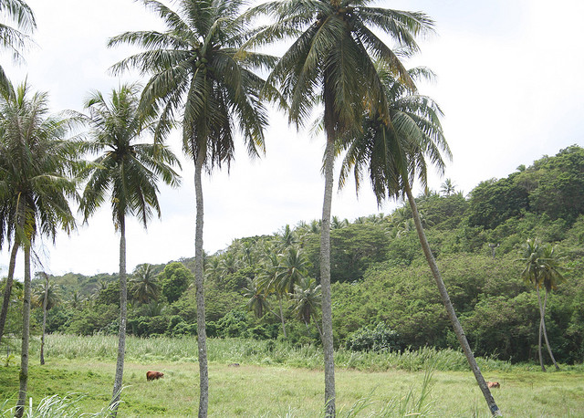(Photo Courtesy of Guampedia)
At foothills of the village lies the coastline of Pago Bay. Along the bay, are the cliff lines that lead up towards a beautiful view of the blue waters surrounding the village. But the event that took place here during WWII under the Japanese Occupation is one of worst atrocities in Guam’s history. The Manenggon Valley is located between Yona and Talofofo. It would be here where many lives would be torn to pieces and become the site of the largest concentration camp for many Chamorro families during the last days of the occupation.
On December 8, 1941, a few hours after the bombing at Pearl Harbor, Guam was taken over by the Japanese Government. During the 3 year reign of the Japanese, from December 1941 to August 1944, the Chamorros lived in fear and were at the mercy of many Japanese soldiers. Their inability to practice their traditional lifestyle and language had been taken away from them. On July 10th 1944, the Japanese military had received word that the American forces are about to invade Guam. They quickly forced many Chamorros all over the island out of their homes to march to Manenggon Valley. The march would be a hard and treacherous trek to overcome for many of them, most especially the elderly. Many lives would be lost during the long march and it got worse upon arrival to the camp. Around 18,000 Chamorros populated the camp along the Manenggon river. With no food and shelter, life in the camp would be extremely difficult. The only source of water was along the river and it was to be used for everything, from drinking to washing clothes. It was where majority of Chamorros lived until the first troops from the American invasion reached the area on July 30th 1944.
General Citation
About this lesson
This lesson is based on the National Register of Historic Places registration file, “Manenggon Concentration Camp” with photographs and other source materials provided by the War in the Pacific National Historical Park regarding the Manenggon Concentration Camp. Frankie Mateo, a Secondary Health/PE teacher and Joefred Beatingo, a Middle School Social Studies teacher wrote this lesson. This lesson is one in a series that brings the important stories of historic places into the classrooms across the country.

Where it fits into the curriculum
Topics: This lesson can be used in American History, History of Guam, and Geography courses in units on World War II
Time period: Mid -20th Century
Relevant United States History Standards for Grades 5-12:
Era 8: The Great Depression and World War II (1929-1945)
Standard 3A - The student understands the international background of World War II.
Standard 3B - The student understands World War II and how the Allies prevailed.
Standard 3C - The student understands the effects of World War II at home.

National Council for the Social Studies (NCSS) Standards
Theme I: Culture
Standard B – Students give examples of how experiences may be interpreted differently by people from diverse cultural perspectives and frames of reference

Theme II: Time, Continuity, & Change
Standard A – Students demonstrate an understanding that different people may describe the same event or situation in diverse ways, citing reasons for the differences in views
Standard D – Students identify and use various sources for reconstructing the past, such as documents, letters, diaries, maps, textbooks, photos, and others

Theme III: People, Places, & Environments
Standard B – Students interpret, use, and distinguish various representations of the earth, such as maps, globes, and photographs
Standard H – Students examine the interaction of human beings and their physical environment, the use of land, building of cities, and ecosystem changes in selected locales and regions
Theme IV: Individual Development & Identity
Standard B – Students describe personal connections to place – especially place as associated with immediate surroundings

Theme V: Individuals, Groups, & Institutions
Standard E – Students identify and describe examples of tensions between and individual’s beliefs and government policies and laws

Theme VI: Power, Authority, & Governance
Standard F – Students identify and describe factors that contribute to cooperation and cause disputes within and among groups and nations

Theme IX: Global Connections
Standard F – Students investigate concerns, issues, standards, and conflicts related to universal human rights, such as the treatment of children, religious groups, and effects of war

K-12 Content Standards for the Guam Department of Education (GDOE)
Grade 7: World Geography
Standard 7.3.1: Interpret maps, globes, satellite images, photographs, or diagrams

Grade 8: U.S. History from Reconstruction to Present
Standard 8.2.9: Identify the major causes and effects of American
Involvement in World War II

High School: Guam History
Standard GH.2.3: Identify and describe historical periods and patterns of change during the eras of Guam history, including the Japanese occupation

High School: U.S. History from Ancient Times to Present
Standard US.2.13: Examine the events of World War II
Standard US.2.14: Describe the effects of World War II on the home front

High School: World Geography
Standard WG.2.1: Apply and synthesize key concepts, such as chronology, change, conflict, and complexity
Standard WG.3.1: Analyze maps, globes, satellite images, photographs or diagrams

High School: World History from Ancient Times to Present
Standard WH.2.26: Assess the worldwide impact of World War II
Objectives for Students:
- To understand the significance of the hardships the Chamorro people endured marching to Manenggon Concentration Camp during WWII.
- To explain the cause and effect of events that occurred during the Japanese Occupation of Guam.
- To identify the many hardships the Chamorro people were faced when they were forced live in a concentration camp.
- To research some of the different first-hand accounts of actual survivors of the march to Manenggon.
Materials for Students:

The readings, photographs, and maps listed below can either be used directly on the computer or can be printed out, photocopied and distributed to students.

- Readings: Each of the readings provide a detailed account of events that occurred during the march to Manenggon Valley on July 10th 1944. The first reading talks about the first accounts of the United States Army soldiers of the 77th Division and the local Chamorro’s who were part of the march to Manenggon; the second reading are from the first-hand accounts from the late Governor Bordallo’s autobiographical manuscript entitled “Uncle Sam’s Mistress”.
- Two Maps: The first map explains the American military offensive strategy to recapture the island in the 1944 Battle of Guam; the second map shows the different areas the Japanese Government occupied during 1942. It also shows a timeline of the all the different major battles in the Pacific area.
- Three Photos: The first photo shows women washing clothes along the Manenggon River during their encampment in the valley; the second photo shows American military soldiers walking across the island to secure on of the sites where the Chamorros were being held captive; the third photo shows a woman being carried into the Manenggon Concentration Camp site after marching for days.

Teaching Activities

Getting Started

Inquiry Question

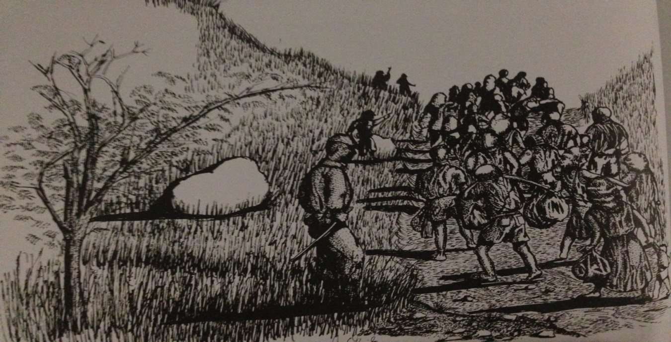
(Jimmy Garrido/War in the Pacific National Historical Park; Don A. Farrell, The Pictorial History of Guam pg. 34)

- Depiction of the march into Manenggon Valley. Describe the drawing, in a few sentences, how the Chamorros might have felt walking for days.

- What might have happened to those Chamorros who were not able to march the whole way to the Manenggon Valley?

- Do you think the Japanese soldiers tortured them during the march to the campsite?

Setting the Stage

The Japanese attack on Pearl Harbor had significantly damaged the U.S. Pacific Fleet. Within a couple of hours after Pearl, on December 8th 1944, the Island of Guam was to feel the wrath from the same invasion by the Japanese military. The surprise attack had the Chamorros scrambling for their lives. It would be the start of a long, three-year occupation that would cause horrific memories for the people of Guam.

Japanese forces strategically bombed the naval shipping and communication facilities located in Sumay. They worked their way along the west coast of the island bombing the village of Piti and Hagatna immediately after the initial rampage on Sumay. At this time there had been a good number of residents in Hagatna celebrating the feast of the Immaculate Conception. It quickly turned Hagatna into a city of terror and chaos. The bombing along the coastline lasted throughout the day. The American forces on Guam could not sustain the Japanese.

It wasn’t until the 10th of December when the Japanese fully invaded the island, that then Naval Governor of Guam George McMillin surrendered. American forces were not able to sustain a battle force of almost 6,000 Japanese soldiers. Within a couple of months after the invasion, under the complete control of the Japanese, the island was used as a military camp. Life for the next 2 ½ years would be disastrous. Close to 1,200 Chamorros killed, and another 14,000 plus suffered atrocities of war.

On July 10th 1944, Japanese military leaders forced all Chamorros out of their homes throughout the island. Thousands of people were ordered to march south towards the Manenggon Valley. This forced march would be the start of a very tough week ahead prior to the liberation of Guam. Over the next several days, the death march would claim many lives. The long march over roads and trails was extremely tough on the people. They did not have food or water. Soldiers would beat up those tried to sneak away from the path to get food or water. The weak and elderly who did not make it to the camp site were left on the side of the road to die.

Over the next couple of days, massacres took place all over the island that would leave a haunting memory for most survivors. The atrocities in Tinta, Faha, and Fena caves would account for a huge number of deaths in a span of days. The survivors after the liberation had expressed that the last three weeks of the Japanese occupation of Guam was the most difficult to cope with. The massacres at the three different caves were a sign that the Japanese were not going to outright surrender to the Americans. The Japanese had reined terror during those years and with the Americans coming to recapture the island the Japanese were not retreating. The Japanese soldiers had one thing in mind, which was to fight to the end. Being a prisoner of war was not one of their choices. Unsure of how they were to be treated as one, fighting until the end was the natural choice during times of war.

Locating the Site

Map #1: Battle of Guam 1944

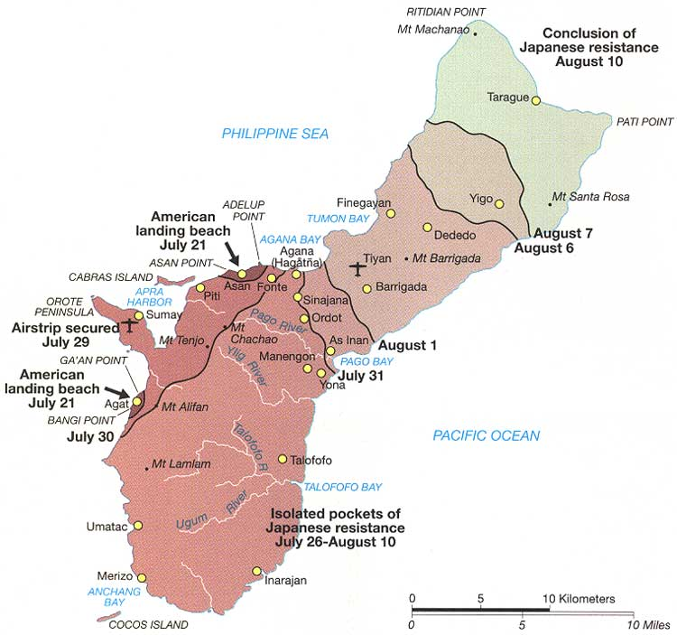
(Photo Courtesy of the National Park Service)

This map shows the start of the American invasion and liberation of Guam in July 21, 1944. The American forces took a total of three weeks to from start to finish in order to clear all areas occupied by the Japanese.

Questions for Map #1

- Build a timeline for the areas the Americans started and ended during the Battle of Guam in 1944.
- Why do you think the northern area of the island was the last to secure for the Americans?
- What area took the American forces longer to secure from Japanese resistance?

Locating the Site

Map #2: Japanese controlled areas 1942

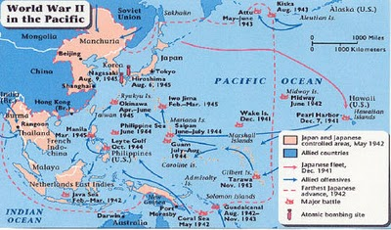
(Photo courtesy of america-at-war-wwii.weebly.com/island-hopping)

With Japan slowly taking over in the Pacific and the Nazi's advancing in Europe, the Allied nations grew worried. The United States was asked to join on the Allied side, but the US still had strong isolationist attitudes left over from the first Great War. Japan bombed Pearl Harbor, Hawaii, on December 7th, 1941, three years after the beginning of the conflict. The United States had no choice but to now join the war it was trying to avoid.

Questions for Map #2:

- What did the U.S. forces do at the same time they were securing the island of Guam?

- What two areas did the United States retaliate against the Japanese? What are the exact dates did those events happen?

Determining the Facts
Reading 1: Pursuit Phase

The machine guns fired into the flimsy huts, from which the Japanese could put up only slight resistance. As the last buildings were neared, the enemy survivors fled into the jungle beyond the village. They left behind a considerable supply of hand grenades, small arms, and ammunition. One of the buildings, obviously used as a Japanese barracks, was littered with dirt and trash and looked as though it had never been cleaned. The natives stated that Yona had been a supply center and garrison for several hundred soldiers, and that they had been forced to work for the Japanese.

The skirmish at Yona made the men of the 3d Battalion, 305th, uneasy about the night, for they were getting close to areas which might be well defended. They arrived near the south bank of the Pago River after dark and set up their perimeter on a hill overlooking the bay. Their uneasiness increased as the hour grew later because they had little time to dig fox holes in the hard coral, and their perimeter was separated from the 307th to the left by a large gap. During the night they once heard Japanese marching on the road below and held their fire in order not to attract the attention of any large group of enemy that might be near. However, the night passed without any further alarms.

An outstanding event of the day for the "Statue of Liberty" Division was the liberation of 2,000 Chamorros who were huddled in a concentration camp near Asinan. Patrols of Company L, 307th, found the camp unguarded. They let the natives out and directed them back toward their homes on the west side of the island. The ex-captives were almost beside themselves with joy. Not knowing whether to kiss their liberators, bow to them, or shake hands with them, they tried to do all three at once. Many carried tiny American flags which they had hidden from the Japanese. "We wait long time for you to come," some of them said. Their faith in the return of the Americans had apparently never faltered, although as one Chamorro scornfully said, "We were told by the Japanese that the U. S. A. was being defeated, that Japan had control of the Hawaiian Islands, and that the Americans had only one ship left as the rest had been sunk."

The weary infantrymen were immensely moved by the joy of the natives as they passed back through the lines. Soldiers who had been complaining because their rations were low gave away what ·few cigarettes they had. While watching the tiny children who carried huge baskets, and the women who trudged along with half their household possessions on their backs,' the soldiers realized the meaning of liberation for these enslaved people.

Questions for Reading #1

- How useful were the native Chamorro’s in aiding the 3rd Battalion of the 305th Division as they settled in the Pago Bay River knowing the enemy soldiers were near?

- Draw some conclusions as to why infantrymen were "immensely moved" as native Chamorro’s passed through the lines that they would give away what provisions they had left?

(The first reading was excerpted from “Guam Operations of the 77th Division: 21 July – 10 August 1944” is one of a series of fourteen studies of World War II operations originally published by the US War Department’s Historical Division. Pg.63-70.)

Determining the Facts

Reading 2: Journey to Manenggon

The American bombardment began on July 8, 1944, and continued until July 20. The Americans threw everything they had at the island. The continuous pounding nearly drove us insane. There was no escaping the noise. During a barrage, we couldn't speak, couldn't think. We could do nothing but wait for a lull and blessed silence. The lulls were painfully brief. As soon as our ears stopped ringing, the bombardment would begin anew. We would dive back into the shelter, muffle our ears as best we could, and cower in fear again.

At the height of the bombardments, Japanese authorities ordered all civilians into designated campsites around the island. The order was issued on July 10. We learned of the order a day or two later. Once again, we packed our belongings into the bullcart ... we packed only a few items of clothing and some tools. Our main concern was our food supply. Mama had foreseen such an emergency and had stockpiled ample stores.

We didn't know why we were being concentrated or how long we were to be held. We didn't know if we would survive. As usual, Mama took roll before we set out. There was Daddy, Irene, Lorraine, Bobbie, Paul, Norma, Fred, Rodney, Donald, Junie, Josephine, Michael, baby Rosamunde, me, our little Indian bull and Paul's fully loaded bullcart. We left Pado and joined other refugees on the trail. A huge throng of people was already at Tai when we arrived. The larger group had been removed from Yigo to make way for the Japanese stronghold and had been herded to Tai a day before us. Throughout the night and well into the next day, groups of people from other parts of the island arrived steadily. The Tai encampment soon turned into a sea of humanity wallowing in mud.

Later that morning, the Japanese routed the encampment and the march to Manengon began. Thousands of people arose slowly from their makeshift camps and prepared to move out. Precious belongings — pathetic bundles of every size and description — were carefully lashed onto bullcarts or shouldered by their owners. Fear filled the faces of every man, woman and child. At a barked command, a column of soldiers with fixed bayonets began the march. ... The seething chaos of humans and animals compressed and uncoiled slowly, like a huge snake. Flanked by armed soldiers, the great human snake inched forward.

More people joined the march when we reached the Chalan Pago crossroads. From there, we descended the steep road down to the Pago River.

Just before we entered Yona, a bullcart, about two or three carts ahead of ours, broke down and halted progress. Hannah Chance Torres and her children were passengers. Like everyone else in the column, I could only watch as a soldier made his way towards Hannah's cart. He then jabbed his bayoneted rifle toward her in a threatening manner. Hannah began to scream. The soldier stormed off in disgust, but Hannah continued to shriek hysterically. ... She never recovered from the terror. Exhaustion eventually reduced her to semi consciousness. She whimpered all the way to Manengon and gave up the will to live.

The Japanese would not allow a slow, careful descent into the Manengon valley; instead, they drove everyone downward at gun point. Just before we began our descent, heavy rain began to fall again. Soon, rivulets of rainwater and mud began to wash down the slopes. Blinded by the darkness and the rain, people slipped and fell, tumbling helplessly until they slammed into rocks, trees, or other people. Men, women and children dug their feet into the mud and tried desperately to keep heavy bullcarts from careening downward out of control.

In the wee hours of morning, I heard a man's voice calling out softly in the eerie silence, "Felix, Felix, mungi hao? Maila sa chachaflik si Hannah." Someone was calling Felix Torres, Hannah's husband. "Felix, Felix, where are you" the voice had said, "Come, because Hannah is dying." When we awoke at daybreak, Hannah Chance Torres was dead. Felix and his family wrapped Hannah's body in a blanket and buried her near the camp. In the days that followed, many other burials took place in and around the camp.

………..As human and animal wastes piled up each day, the odors grew more and more foul. Soon, the whole camp reeked with a most horrible stench. The small stream that coursed through the valley was our only source of water. With several thousand people using it daily, it quickly turned into a cesspool.

Once in a while, an American plane would fly over the camp and stir up everyone's excitement. On one such occasion, my brothers and sisters and I were splashing around with some other children in a popular swimming hole not far from the camp. As we splashed in the water, the American plane appeared overhead. It circled directly above us and came in closer. It flew so low that it barely cleared the treetops. Some of the children even claimed that they saw the pilot's face. Before I could yell, "Wave and smile at him, or he'll shoot us," my companions were jumping up and down and cheering enthusiastically.

When the pilot dipped his wings in acknowledgment, we got even more excited. But seconds later, our excitement turned to fear. The pilot suddenly opened fire with his machine gun. For an instant we thought the American was going to mow us down. Then suddenly, a man tore out of the machine-gunned thicket. His hands were tied behind him and he was barefoot. As he disappeared into the jungle, a Japanese patrol emerged from the thicket. I learned from my cousin, Joaquin Pangelinan, that the man was Ignacio "Kalandu" San Nicolas who had been scheduled for execution that day. The grave in the banana grove was to be his. The American pilot's machine gun fire scattered Kalandu's executioners long enough to allow his escape.
I was sitting in a thicket when I began to hear a strange sound rising from the camp. I could hear people laughing and shouting and whistling. Moments later, I heard my name. It was Paul. He galloped toward me, hollering"Hurry! The Americans are here!" We ran down the hillside and into the frenzy in camp. People were laughing and crying, hugging and kissing, shouting and jumping, dancing and singing. I worked my way into the densest part of the crowd and found Dad. Together, we elbowed our way toward nine dumbfounded American soldiers.
The Americans had not expected such a reception or so large a crowd. One of the soldiers was shouting and holding his rifle above the surging mob. "Follow" was all anyone heard. The word spread quickly: follow the Americans. Within a few minutes, hundreds of people fell into line and followed obediently behind the dazed Americans. The camp guards panicked and fled.

From the Manengon valley, the great throng climbed into the hills and headed west. We followed paths beaten down by soldiers who had fought their way up from the Agat beachhead. When we reached the slopes above the coast, we were greeted by the incredible panorama of American military might. Agat Bay was speckled by hundreds of ships of different shapes and sizes. There were so many, they darkened the ocean all the way to the horizon. The sight was awesome.

Questions for Reading # 2
- How did the constant bombardment of artillery assaults psychologically affect native
Chamorro prisoner of war?

- What kinds of emotions overwhelmed the native Chamorro as their eyes gazed upon the
presence of American Military ships?

- Because Chamorro prisoners were forcefully marched at gun point through the foothills of mannequin, what was the fate of those whom were fatally wounded and sick during the march?

(Reading 2 was adapted from the National Park Service. It was produced by the publications subcommittee of the Golden Salute Committee for the observance of the 50th Anniversary of the Liberation of Guam, 1944-1994.)

(This article was extracted from the late Governor Bordallo's autobiographical manuscript entitled "Uncle Sam's Mistress." Copyright 1987: R.J. Bordallo)

Visual Evidence

Photo #1: Camp Life

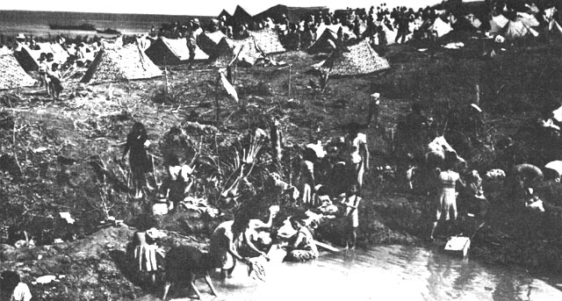
(Photo courtesy of the National Archives/National Park Service)

The picture shows women washing what clothing they had been able to carry to the Manenggon Concentration camp. Japanese soldiers patrolled the living area constantly to ensure the camp residents were not able to escape the campsite.

Questions for Photo#1:

- Looking at the photo, list some of the hardships the Chamorro’s faced by being held captive in the concentration camp?

- What do you think the people living in the camp used the body of water for besides washing clothes? List as many as you can.

- Do you think people who survived the concentration camp had any psychological problems after the Americans recaptured the island?

Visual Evidence

Photo #2: Crossing Paths

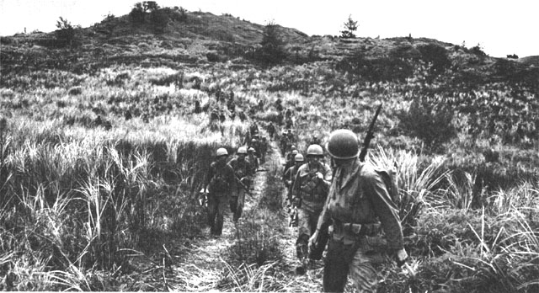
(Photo courtesy of National Archives/National Park Service)

Questions for Photo #2:

- As a young American soldier, describe in your own words, the difficulty of marching with military equipment in this type of terrain?

- How do you think the Chamorro’s felt when they met up with all of these American soldiers for the first time during the Japanese Occupation?

- Do you think many of the American soldiers ever returned to Guam after they helped liberate the island?

Visual Evidence

Photo #3: The Journey Ahead

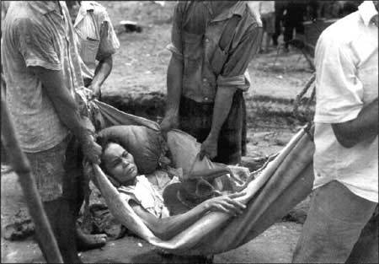
(Photo courtesy of National Archives/National Park Service)

Question for Photo #3:

- Looking at the picture above, what part of the march do you think this occurred? Beginning? During? Or End? Why?

- In your own words, writing 3-4 sentences, give a proper caption for the picture above.

- Have you ever met anyone who has survived the March to Manenggon?

Putting it All Together

The following activities will help demonstrate to students the significance of the March to Manenggon prior to the recapturing of the island of Guam. It will also help develop a better understanding of World War II and the events in the Battle of Guam in 1944.

Activity 1: Commemorating the Victims of Manenggon

Students will have to be creative in this activity. They have the option to create a memorial commemorating the victims of the march to Manenggon. Sky is the limit!!
- Students can create a painting or collage to honor the victims.
- They are able to make a model by sculpting a memorial piece dedicated to the victims.
- Design a t-shirt/poster honoring the victims of the march.
- Design/create a website commemorating the Chamorro victims who suffered at Manenggon.
- Create a blog to help people cope with the different atrocities of war.

Activity 2: Find one!!

Students will find one survivor of the Manenggon march OR a soldier who participated in the liberation of Guam. With guidance from the teacher using the basic interviewing process of questioning, students will have an opportunity to research for individuals who were part of this historical event. If students are unable to find a person of interest, they will then research different firsthand accounts of survivors/soldiers that have been documented.

Upon researching an individual, students will write a semi-autobiography of that person. Students should be able to understand the many hardships the Chamorro people endured during this event that changed many lives. Also, through the military personnel who landed on Guam to liberate the Chamorro people and how they saw firsthand how the Japanese military treated the Chamorro’s during their occupation of the island.

Activity 3: Compare and Contrast

Students will find as many photos of historical landmarks on Guam. Chose one or two that they are able to obtain a present day photo of the site. They will write an essay comparing and contrasting the two photos, the old and the new. The essay will be two pages or 6 paragraphs in length. Some guideline questions to follow are:
- What is the era/period?
- What was it before? What is it now?
- Did any important event happen there?
- Who are the important/significant persons involved with the site?

Supplementary Resources

Manenggon: Death March will help students learn about the many hardships the Chamorro’s encountered during the Japanese Occupation. The atrocity during the Manenggon March would be an event that many survivors would never forget. They will also be able to develop a better understanding of the events that took place during the Battle of Guam in 1944.

The Pictorial History of Guam: Liberation – 1944, by Don A. Farrell. 1984
This book is one of a series of books written by Don A. Farrell. According to the author:
“the primary purpose of this book is to help record the story of the Chamorros and the events that make up the history of their island. Their story is one of survival, of meeting the onslaught of progress, while still maintaining their unique cultural identity. And, as recounted in this volume, of confronting with courage, the hardships of occupation and the horrors of war.”
Mr. Farrell hopes that the next generations of Chamorro understand the amount of lives lost, as well as what the American soldiers went through to recapture the island. The photographs in the book should help people understand the hardships and sacrifice that was put on the line will not be forgotten.

Guam Historic Resources Division
The Guam Historic Resources Division, also known as the State Historic Preservation
Office (SHPO), implements projects and activities that promotes the use, conservation, preservation, and presentation of historic properties. The website includes a listing of historic property in Guam as well as laws, regulations, and guidelines concerning historic properties. Teachers will also find a gallery of historic sites with downloadable brochures, posters, and photos. Their website can be found at http://historicguam.org/index.html.

Guampedia Foundation, Inc.
Guampedia Foundation is an independent non-profit organization. Guampedia, Guam’s
Online Encyclopedia, is a community project to create a comprehensive online encyclopedic resource about the history, culture, and contemporary issues of Guam. The website has 15 entries that focus on various people who lived through World War II, war atrocities, religious life during the war, and life on Guam from occupation to liberation. Their website can be found at www.guampedia.com.

Guam Preservation Trust
The Guam Preservation Trust (GPT) was created in 1990 as a non-profit, public corporation governed by a Board of Directors. It is dedicated to preserving Guam’s historic sites and culture as well as educating the public about those issues. Their website, www.guampreservationtrust.org, includes a plethora of pictures of historic structures pre-war and post-war Guam.

Liberation: Marines in the Recapture of Guam
Written by Cyril O’Brien, this digital pamphlet is one in a series devoted to US Marines in the World War II era. It was published for the education and training of Marines by the History and Museum Division, Headquarters, U.S. Marine Corps, Washington DC, as part of the US Department of Defense observance of the 50th anniversary of victory in that war. It was transcribed, formatted by Jerry Holden for the HyperWar Foundation, and can be found at http://www.ibiblio.org/hyperwar/USMC/USMC-C-Guam/. The website also includes maps and photos of the Battle of Guam.

National Park Service
The War in the Pacific National Historical Park provides detailed resources about World
War II in Guam. Their website, www.nps.gov/wapa, showcases World War II photos and multimedia. It also includes links to pages, digital books, and articles (sponsored by the National Park Service) relating to the battles across the Pacific Theater, including Guam. There are also digital brochures and literature that can be downloaded to learn about the events that led to the outbreak of the Pacific War, the Battle of Guam, and the role the Mariana Islands played in helping to end World War II.

U.S. Army Center of Military History
The document, “Guam Operations of the 77th Division: 21 July – 10 August 1944” is one of a series of fourteen studies of World War II operations originally published by the US War Department’s Historical Division. It provides a concise summary and maps of the campaign for Guam during World War II and can be found at <http://www.history.army.mil/books/wwii/guam/guam77div-fm.htm>.

