Historic Hagåtña

Introduction

Long before Marco Polo set out on his voyage to China, and more than a thousand years before the Polynesian ventured out in their canoes to find their islands, and about the same time the Egyptians were building *the Sphinx*, Chamorros lived and thrived in Hagåtña. Older than San Augustine, the oldest city in North America or even San Juan the oldest American city in the Atlantic Basin. Hagåtña was a prominent village long before [colonization](https://en.wikipedia.org/wiki/Colonization) by the Spanish. In 1668, the first Spanish [missionary](https://en.wikipedia.org/wiki/Missionary), Padre [San Vitores](https://en.wikipedia.org/wiki/San_Vitores) arrived on the island. Recognizing the importance of Hagåtña, San Vitores allowed himself to be convinced to live in the most important village. The most prominent chief of Guam donated land in Hagåtña enabling San Vitores to build the first church (Dulce Nombre de Maria Cathedral-Basilica) on Guam.

Under Spanish rule, much of the indigenous population of Guam and other [Mariana Islands](https://en.wikipedia.org/wiki/Mariana_Islands) was forced to relocate to the city. The remains of buildings from the Spanish administration can be seen in the Plaza de España located beside the cathedral of the [Archdiocese](https://en.wikipedia.org/wiki/Archdiocese) of Agana.

After Guam was ceded by [Spain](https://en.wikipedia.org/wiki/Spain) to the [United States](https://en.wikipedia.org/wiki/United_States) in the [Spanish–American War](https://en.wikipedia.org/wiki/Spanish%E2%80%93American_War) of 1898, 'Agana' remained the seat of government under U.S. Naval Administration. By 1940, the city's population had grown to more than 10,000 people, containing nearly half of the island's residents.

Guam was captured by [Japanese](https://en.wikipedia.org/wiki/Japan) forces on December 8, 1941. During Guam's 1944 liberation from the Japanese during [World War II](https://en.wikipedia.org/wiki/World_War_II), the city was heavily damaged by U.S. naval bombardment. Many former residents settled in other parts of Guam after the war. As part of Guam's reconstruction plan, the [U.S. Navy](https://en.wikipedia.org/wiki/U.S._Navy) constructed new straight city streets that passed through existing lots and created many plots of land with multiple owners. This has hindered the development of the city to the present day. Today, despite a resident population of less than 1,100 (less than 1% of Guam's total), the city remains the seat of the territorial government. Its historic sites are major attractions for visitors.

General Citation

About this lesson

This lesson is based on the Guam Register of Historic Places nomination file, “Historic Hagåtña” (with photographs) and other source materials regarding the village and its history. This lesson was written by Elizabeth Reyes, a teacher with Guam Department of Education. This lesson will attempt to show how Hagåtña has changed physically and socially through the different eras, it will look at how Guam continues to reinvent Hagåtña and preserve its unique history.

Where it fits in the curriculum

Topics: this lesson can be used in History of Guam, American History and Geography

Time Period: About2 000 B.C. to present.

*National Council for Social Studies Standards*

Theme 1: Culture

Standard A – explore and describe similarities and differences in the ways groups, societies and culture address similar human needs and concerns.

Theme 2: Time Continuity and Change

Standard B – demonstrate an ability to use correctly vocabulary associated with time

such as past, present, future and long ago; read and construct simple

timelines; identify examples of change; and recognize examples of cause

and effect relationships.

Theme 3- People Places and Environments

Standard C – use appropriate resources, data sources and geographic tools such as,

atlases, data bases, grid systems, charts, graphs, and maps to generate,

manipulate and interpret information.

Standard D – estimate distance and calculate scale.

Theme 4 – Individual Development and Identity

Standard B – describe personal connections to place-especially place as associated with

immediate surrounding

Theme 5- Individuals, Groups and Institutions

Standard E – identify and describe examples of tensions between an individual’s beliefs

and government policies and laws.

Theme 6 – Power, Authority and Governance

Standard C – give examples of how government does or does not provide for the needs

and wants of people, establish order and security and manage conflict.

Theme 10 – Civic Ideals and Practices

Standard E – explain actions citizens can take to influence public policy decisions.

Common Core Standards for Literacy in History/Social Studies 9-10

CCSS.ELA.RH.9-10.3. - Analyze in detail a series of events described in a text;

determine whether earlier events caused later ones or simply preceded them

CCSS.ELA.RH.9-10.6. Compare the point of view of two or more authors for how they treat the same or similar topics, including which details they include and emphasize in their respective accounts

**K-12 content standards for the Guam Department of Education (GDOE)**

High School Guam History

Standard 2.1: examine and interpret primary and secondary source document.

2.3: Identify and describe historical periods and patterns of change during the

eras of Guam History, including, Ancient Chamorro society, Spanish

Colonization, U.S. naval Government, Japanese occupation, post WWII

and Modern Guam.

3.4: Locate places and plot geographic grids using latitude and longitude

High School U.S. History

Standard 1.1: analyze primary and secondary source documents, records and data

including artifacts, dairies, letters, journals, photographs, newspapers,

historical accounts and art to increase understanding of events and life in

the United States

2.1: Describe the effects of World War II on the home front including the U.S.

liberation of Guam

High School World Geography

Standard 3.1: Apply geographic skills and reference sources to understand how

relationships between humans and their environment have changed over

time

**Objectives for Students**

1. Identify challenges that the residents of Hagåtña have faced in the economic, political, and other spheres of life, and explain how they have responded to those challenges.
2. Assess the significance of key turning points in world history
3. Reflect upon choices humans have made in the past and consider how choices made today may affect the future.
4. Compare the world we live in today with past eras.

**Materials for Students**

* 1. Three readings: The first reading describes the ancient village of Hagåtña as found by San Vitores; the second reading is an account of how people in power have tried to rebuild the City after WWII; the third reading are testimonies of Chief Hurao and Hope Cristobal.
  2. Two maps: The first is a map of the island of Guam; the second shows Guam and its Pacific neighbors.
  3. 2 videos: The first video show life on Guam before WWII; the second video show the shelling of Guam.

Getting Started

Inquiry Question

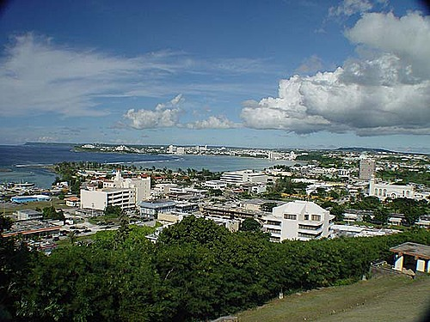

1. Examine the photograph. In the foreground of this photograph is the city of Hagåtña. How would you describe Hagåtña?
2. What details do you notice?
3. What other information-such as time period, location reason photo was taken- can you gather from this photo?
4. What emotions might one get from looking down at Hagåtña from this vantage point?
5. What questions do you have about the Photograph? How might you find answers to these questions?

Setting the Stage

Agana at Night

A City without a soul is not a city. And Agana, once the proud seat of humanity in the little known Marianas lost her soul two decades ago and has shown little inclination to reassert herself, and perhaps someday recapture the glory that was once hers.

Agana, the eyes and ears of Guam many years age, is still in a slumber, alive only because life must be lived but indifferent to her past and seeming unconcerned about her future.

Look about the city, home of 10,000 souls before the great war 23 years ago. With the exception of several isolated areas where there are small pockets of homes, the city is barren, devoid of life.

PEOPLE FLOCK to Agana from near and far during daylight hours but only because there are jobs to be done, necessities to be obtained, taxes to be paid. Once the clock strikes five emptiness returns and sniffs the air once breathed by noble souls who rollicked and cried, danced and brooded in the city that no longer is.

But there are still people living in Agana.

Yes.

And Agana is still the seat of government.

Yes.

But where is proud San Nicolas, the city within a city, the district that was second to none in affluence and spirit. Where is rambunctious San Antonio by the sea, where togetherness was a virtue and all San Antonians were virtuous, according to San Antonians. And where is San Ignacio, the heart of civilized Agana. Or Togai hugging the cliff. Where is Santa Cruz, Bilibic and Ulale. Where is Minondo.

OH, YES, WE see people moving here and there, doing the things that must be done. But the spirit of the city is gone, leaving behind only remnants of her glowing self.

Oh, yes there are signs of life along the great thoroughfare. There are places to eat, drink and be merry. There are caterers to the human needs. Indeed, there many people in Agana. But most of them come to visit, not to dwell within her bosom.

Agana is not the girl we used to know.

*Pacific Profile April 1964 author unknown*

*\*grammatical errors were left to reflect the original document as printed.*

LOCATING THE SITE

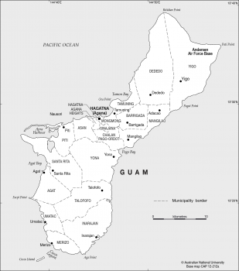

asia pacific.au.edu.au

1. In which section of Guam can Hagåtña be found?
2. How far away are the most northern and southern villages from Hagåtña?
3. Why did Hagåtña’s location make it ideal as the center of Government and commerce?

LOCATING THE SITE

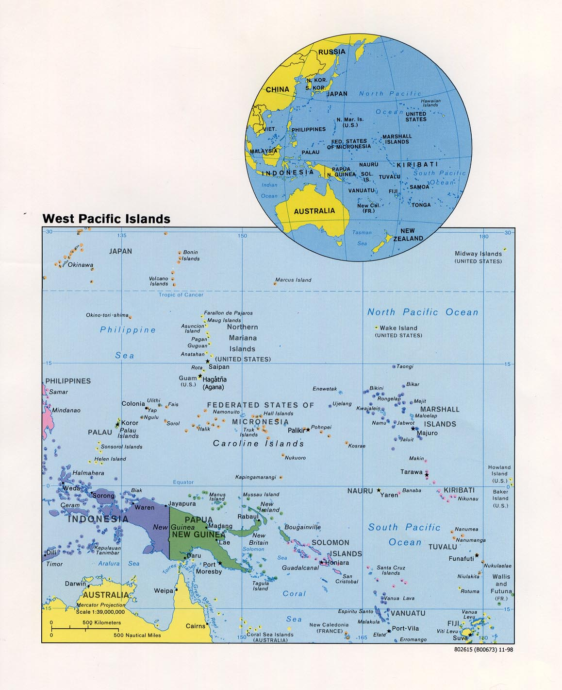

World of maps.net

Identify Hagåtña’s

-Island

-archipelago

-region

-latitude and longitude

-relative location from major neighboring countries

Determining the Facts

Reading 1

180 villages

Padre San Vitores estimated the number of villages in Guam at 180 during his time here. The larger villages along the coast had anywhere from ten to over 150 huts, depending on the size of the clan and importance of the village. Interior villages were generally smaller settlements.

Districts

Villages within defined areas made up a district. Prominent villages of the pre-Spanish period ran from Litek’jan (Ritidian), Hinapsan Jjinapsan), Talague (Tarague), Hilaan, Tumhom (Tumon), Hagat (Agat), Humatag (Umatac), Malesso (Merizo) and Inalahan (Inarajan) on the southern part of the island. Chochogo in what is now Toto, Paasan in what is now Agana Heights, Meppo in Fena, Pulantat in Yona and Gueos in Merizo, were among the most prominent interior communities.

By all accounts, the most important district was **Hagadnia (Agana**) where some of the island’s highest ranking chiefs resided. It was here, too, where the ancient traditions and protocols were strictly enforced. The Spaniards quickly recognized the importance of Hagadnia to the Chamorros of the Marianas. So they established their church mission, military headquarters and eventually their seat of government in this important village.

Recognized boundaries

Districts of the period had fairly well defined and recognized boundaries. They used natural landmarks, such as bay or cove, river, hill, as well as such long lasting trees as dogdog (wild breadfruit), nunu (banyan), ifil and coconut. Except for those villages in the interior of the island, district jurisdiction covered not only the land within the district but also the sea fronting it, extending out to the reef or as far as the naked eye could see beyond the reef. Beyond that, the sea was opened to all. So, too, were large tracts beyond village boundaries where hunting for birds and gathering of edibles were generally opened to all.

Hagadnia in prehistoric period took in all the areas fronting Agana Bay from Oka and Satpon Point to the east where the Guam Memorial Hospital is now located, to Adelup Point to the west; as well as the surrounding communities of Maite, Mongmong, Tutujan, Apugan, and Paasan in Agana Heights.

On Guam there were over twenty major districts, some larger and more prominent than others. Some of them had as many as a thousand huts, according to Fr. Los Angeles’ account.

Discussion Question

1. What do you think are some of the reasons that made a village prominent?
2. What advantages might coastal villages have over inland villages during the ancient period?
3. How might one Maga Lahi (chief) have a higher rank than another Maga Lahi?
4. Why do you think boundaries to the sea were set only as far as the naked eye could see?
5. What might explain why there were so many villages?
6. Using the old Hagåtña boundaries estimate how much bigger the village will be.
7. How do you think Hagåtña acquired the designation as the most prominent village?

*Reading 2 from Guahan-Guam-The history of our island, p.11 (Sanchez, Pedro) 1998*

Determining the Facts

Reading 2- AGANA’S FRACTIONAL LOT AFFAIR

Agana’s Fractional lots, which have effectively hampered the growth of new Agana for the past 16 years will soon be a page from history if present plans materialize.

A review of how the problem arose, and the solutions which have been proposed, is essential for an understanding of the present approach for the resolution to this vexing and perplexing problem.

The city of Agana, which had a population of approximately twelve thousand (12,000) prior to the war, was almost completely destroyed during the reoccupation by the American forces in July 194. Immediately after the cessation of fighting, consideration was given to rebuilding the city by both the military government authorities and the Agana residents. It was recognized that reconstruction of the city along the old pattern would be impossible if a slum city was to be avoided.

In November, 1944, a petition in the form of a plebiscite was presented to the Island Commander of Guam wherein fifty six per cent (56%) of the recognized owners, representing sixty per cent (60%) of the private property in Agana, requested the Military Government of Guam to plan and lay out the city along modern lines. Action was instituted to plan and lay out the city along modern lines. Action was instituted to obtain Government funds to plan the city and to construct public facilities and Government buildings. A sum of six million dollars ($6,000,000) was allocated by an act approved February 18,1946, Public Law 301, 79th Congress of the United States, for the construction of the civilian economy of Guam. This money was designated to be used for Agat and Agana.

The sum of five hundred thousand dollars from this fund was allocated for use in the necessary purchase of lands by the Naval Government in furtherance of the reconstruction program.

REALIZING THAT MANY of the existing private lots in Agana were sub-standard in size and that the new Agana plan with new lot lines would result in many multiple ownerships, the Island commander decided that the private land problem could be most expeditiously handled by purchasing all lands in Agana and selling to private owners, as modern sized lots, any land not required for public purposes.

In January of 1947 there was submitted to the Guam Congress, a proposal that the Governor use the five hundred thousand dollars as a revolving fund for the purchase for all private lands in Agana for laying out a new city and resale of the new lots to the former residents of Agana. The Guam Congress was to determine priorities of distribution to individual landowners, for the redistribution of such new lots was a matter of interest primarily to those individuals who owned lots in Agana.

During the latter months of 1946 and the first three months of 1947 several of the former lot owners in the City of Agana told the land and Claims Commission of their desire to return to Agana and assume control of their privately-owned lands, some of whom stated thy did not sign the original petition requesting a new town layout and therefore did not consider themselves to be bound by the agreements contained in such petition. Statements made by members of the Guam Congress in its debate on motions affecting negotiations between the property owner and the Government at its March, 1947 session indicate that the agreements contained in the 1944 petition did not represent the will of the majority of the citizens of Agana. The 1944 petition was set aside, and the Guam congress was told that the procedure to be used for the development of the new City of Agana should be in accordance with the desires of the citizens to be affected thereby.

In The Deliberation by the Guam congress in March of 1947 no action was taken whereby the Congress assumed responsibility for certifying priorities to the Governor for each individual property owner of old Agana in the event a new layout was adopted. The Guam Congress decided that the original owners of land of old Agana should have first choice of priority selection, and if these persons did not wish to come back to Agana that members of the original owner’s family should have second choice with a proviso that they shall be limited to two years’ time to make their decision, and with an additional condition that they have priority rights to their old land or as near as possible to their old site. The Guam Congress so informed the Governor of the procedure it desired to be followed with regard to assigning priorities in the redistribution of lots in the layout of the new city of Agana, but in effect placed the responsibility of effecting such priorities on the land representatives of the Governor by negotiation between such representative and the individual land-owners. This condition for fixing priorities was incapable of performance by means of negotiation with the landowners because at least 50% of the old residents of Agana would be unable to get new lot sites near their old lot sites, and such lot owners involved would not give up their private property rights unless compelled by law to do so. This compulsion if done, must be through the action of the Guam Congress.

In April of 1947, in lieu of the Guam Congress’ assuming responsibility for priorities to individual landowners for distribution of new lots in the new plan for Agana, the Governor submitted to the Guam congress, a plan whereby the property owners of the lots in old Agana should be required to accept the plan for new streets and new lots in New Agana in accordance with a zoning ordinance that would not allow construction of building except upon a lot of a minimum size, and, under such plan, the Naval Government would acquire, from private ownership at market value, all lands needed for new streets, park areas, and for the location of public buildings. The private landowners were to assume the burden of conforming with the street and lot layout pattern by individual negotiations for purchase or sale of lands necessary to meet with the limitations and conditions of a proposed zoning ordinance.

On 27 June, 1947, the Governor of Guam submitted a statement to the Guam Congress concerning the rehabilitation and reconstruction of Agana. This statement presented a summary of all action taken up to that date and requested that all property owners review the plan of Agana as presented in order to arrive at a mutual agreement and to allow the construction program to proceed. It was stated that the construction program would be placed into effect on August 1, 1947, unless the Governor was otherwise advised by Guam Congress or by petition from Agana citizens.

In The June Session of the Guam Congress the Chairman of the City Planning Commission reported that the Zoning Ordinances had been approved. This report was adopted in joint session by both houses of the Guam Congress….

Discussion Questions

1. Why did the Americans almost destroy the village of Hagåtña?
2. Why do you think, Hagåtña was razed rather than rebuilt the way it was before the war?
3. Do you think a slum city would have emerged had Hagåtña been rebuilt along the original lines? Why?
4. What is the result of the American style city laid out by the American Administration?
5. What do you think are some reasons why Guam has not corrected the multiple ownership problem of the Hagåtña lots?
6. Why have multiple owner lots led to Hagåtña’s low population.
7. Suggest other reasons why Hagåtña has such a low population.

Reading 2 is written by Paul Souder (Pacific Profiles 1967)

Reading 3

**Chief Hurao of Hagåtña ancient Speech of 1671**

**The Europeans would have done better to remain in their own country. We have no need of their help to live happily. Satisfied with what our islands furnish us, we desire nothing else. The knowledge which they have given us has only increased our needs and stimulated our desires. They find it evil that we do not dress. If that were necessary, nature would have provided us with clothes. They treat us as gross people and regard us as barbarians. But do we have to believe them? Under the excuse of instructing us, they are corrupting us. They take away from us the primitive simplicity in which we live.**

**They dare to take away our liberty, which should be dearer to us than life itself. They try to persuade us that we will be happier, and some of us had been blinded into believing their words. But can we have such sentiments if we reflect that we have been covered with misery and illness ever since those foreigners have come to disturb our peace?**

**Before they arrived on the island, we did not know insects. Did we know rats, flies, mosquitoes, and all the other little animals which constantly torment us? These are the beautiful presents they have made us. And what have their floating machines brought us? Formerly, we do not have rheumatism and inflammations. If we had sickness, we had remedies for them. But they have brought us their diseases and do not teach us the remedies. Is it necessary that our desires make us want iron and other trifles which only render us unhappy?**

**The Spaniards reproach us because of our poverty, ignorance and lack of industry. But if we are poor, as they claim, then what do they search for here? If they didn't have need of us, they would not expose themselves to so many perils and make such great efforts to establish themselves in our midst. For what purpose do they teach us except to make us adopt their customs, to subject us to their laws, and lose the precious liberty left to us by our ancestors? In a word, they try to make us unhappy in the hope of an ephemeral happiness which can be enjoyed only after death.**

**They treat our history as fable and fiction. Haven't we the same right concerning that which they teach us as incontestable truths? They exploit our simplicity and good faith. All their skill is directed towards tricking us; all their knowledge tends only to make us unhappy. If we are ignorant and blind, as they would have us believe, it is because we have learned their evil plans too late and have allowed them to settle here. Let us not lose courage in the presence of our misfortunes. They are only a handful. We can easily defeat them. Even though we don't have their deadly weapons which spread destruction all over, we can overcome them by our large numbers. We are stronger than we think! We can quickly free ourselves from these foreigners! We must regain our former freedom! [DATED: 1671]**

Reading 3 continued

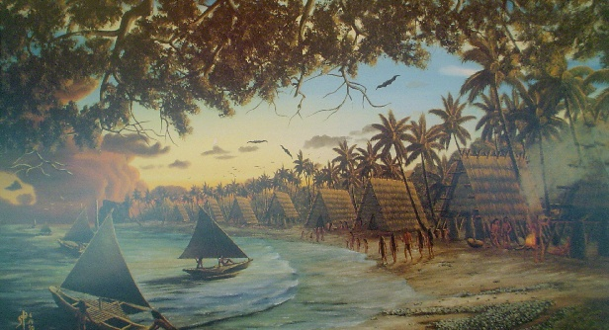 *2015 testimony of Hope Cristobal to the 33 Guam Legislature*

**As an activist, a former University of Guam history professor, I am deeply concerned with the erasing of our Chamorro historic properties, the erasing of place names and the erasing of evidences of our history as a people of Guam. This is a colonial practice that needs to be abated. Our historic properties hold meaning to our people and it is through these meanings and connections that we construct the legitimacy to create and build community. We must cherish and preserve them for the memories and history that lift us up and for the edification of our people – with this caring attitude embodied already in our historic preservation laws – our yet to be written historic narrative will not be empty of substance associated with our heritage – in this case – the Governor Manuel F. L. Guererro Administration building.**

**My dear senators, look around, open your eyes. You can see how little has remained over time from the ravages of colonial occupation of a once sovereign people, a war not of our doing, clearing and grading for urbanization that changed our physical landscape as well as our cultural landscape, the near total destruction of Hagatna, the desecrations and destruction of our ancestors’ sacred burial grounds. The question that we should be asking ourselves, What do we have left that can significantly contribute to our identity as an emerging people? Or, that could contribute to our national pride as a people? Or, that could enhance and enlighten the history of our people? Is the historicity of the Gov. Manuel F. L. Guerrero building and all the activities that make it significant historically, is it worth preserving? I say, YES! The building is not EMPTY nor is it dead space! Know your history! And preserve our historical sites and allow the keeping of our historical integrity. Do not be a part of erasing that history within and through the final plans that will only take up the significance of the Palasyo. Make a stand for a decolonized history, for a better future for our people through the depiction of our struggles as emergent people—a people yearning to restore our sovereignty.**

Discussion Questions

1. Who are Hurao and Cristobal addressing?
2. How are the two speakers alike?
3. How does Hurao propose to achieve his goal?
4. How does Cristobal propose to achieve her goal?
5. What do both speakers want?

Reading 3 Hurao’s Speech **was recorded by French priest, Charles Gobien (English translation)**

**and** *Excerpts from the 2015 testimony of Hope Cristobal to the 33 Guam Legislature regarding the Manuel F. L. Guerrero building*.

Visual Evidence

Set 1

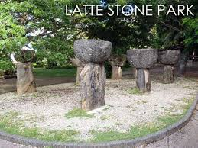



Philippe Godard

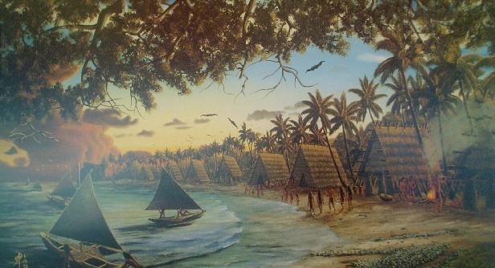

[**Found on ns.gov.gu**](http://ns.gov.gu/hurao.html)

Set one questions

1. Imagine that the painting is of Hagatna, what period in history is it depicting?
2. Where is the place? (relative location)
3. What is the climate (temperature, rainfall)?
4. What physical features can you see in this picure?
5. Describe the people who might have lived there.
6. How did the people use their natural resources?
7. How did people change the land?
8. Why do you think people settled here?
9. How could people travel to this place?
10. How might this place be similar to its neighbors in the region?
11. What would determine the size of this community?
12. What did the ancient people place in the ground between the latte sets?
13. Given that the Chamorus revered their ancestors, what can you conclude about how they kept their home?
14. The Lattes sets in the ***Angel Santos Park*** in Hagåtña were moved from Meppo to make way for development. Agree or disagree with the move, explain your answer.

Visual Evidence

Set 2

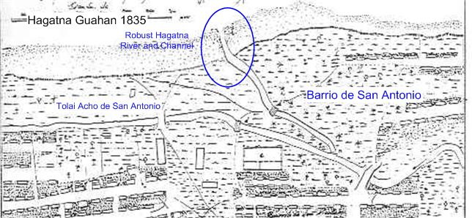

Courtesy of Raul Villaverde All Things Guam

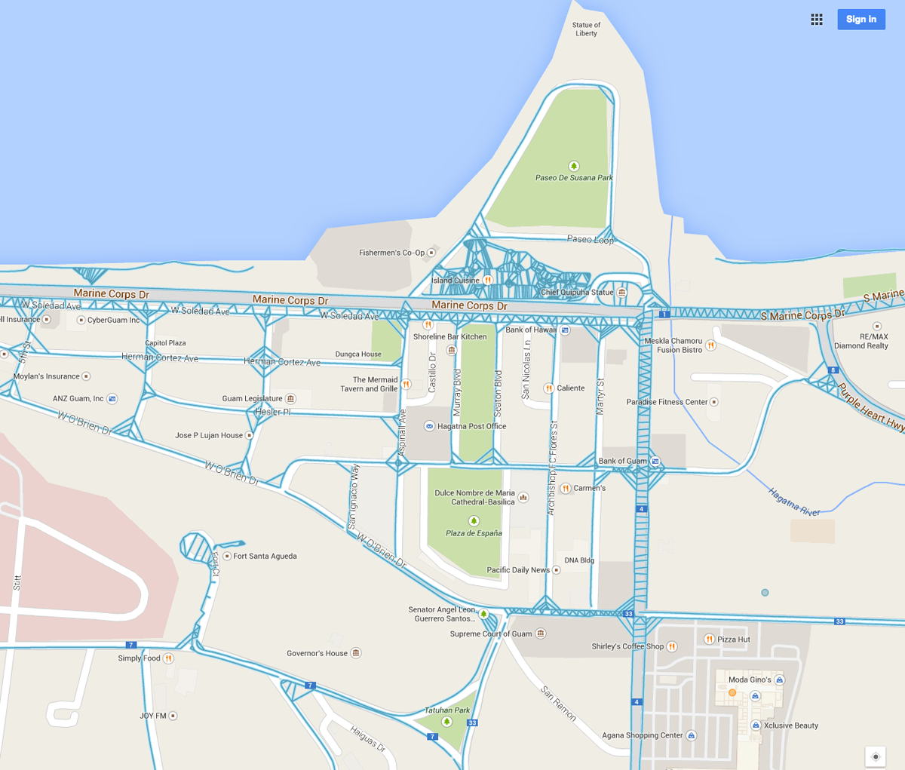

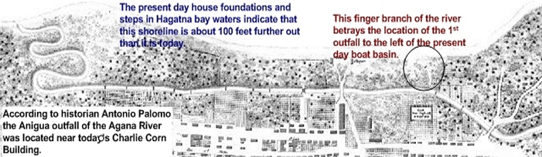

Questions for Set 2

(All maps are of the city of Hagåtña)

1. Locate the bridges on the 1835 map. Trace the river flowing under them and locate where it flows into the Agana Bay
2. Locate the Hagåtña River on the modern map.
3. Compare the two maps, what has happened to the Agana River?
4. What land mass is not shown in the 1835 map? Why?
5. What land mass is not shown on the modern map? Explain what may have happened to cause this change?

Visual Evidence

Photo set 3

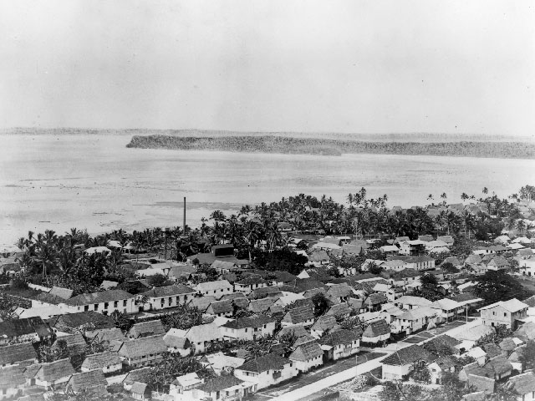

[**Found on ns.gov.gu**](http://ns.gov.gu/hurao.html)

F:\2015 History Methods Class Resource\Hagatna\15 agana ruins.tif

[**Found on ns.gov.gu**](http://ns.gov.gu/hurao.html)

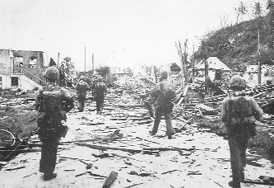

Pacific Daily News file photosHagåtña: Troops walk through the war-torn village of Hagåtña in this file photo

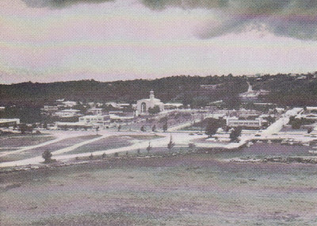

HAGATNA 1962 Posted by Paleric

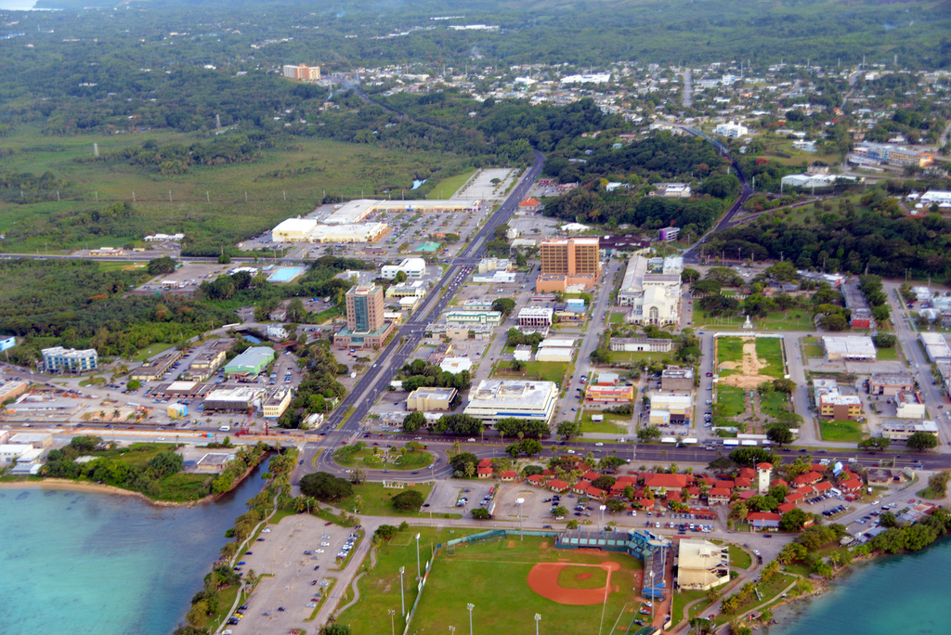

Phot by Bill McKinney

Questions for set 2

1. Examine the five photographs of Hagåtña, what are the biggest differences between the pre-war picture and the modern picture of Hagåtña.
2. Why might the soldiers, seen walking through the World War 2 ruins of Hagåtña, be glad that the City was destroyed?
3. Do you think Hagåtña has made adequate progress recovering from the War? Why or why not?
4. Compare the second and the fifth photographs, what change do you see that may be one of the biggest reason why Hagåtña’s population is so small.
5. Do you think Hagåtña will ever become the population center of Guam again? Explain your answer.

PUTTING IT ALL TOGETHER

The following activities will help students gain a better understanding of the historical significance of the City of Hagåtña, become aware of the historical sites tucked within and about the city that most of Guam residents are not aware of and to understand the value of preserving those historical sites.

Activity 1: Research or visit **The Hagåtña Historical Trail**, identify sites that could

possibly be used for activities to promote awareness of the site and

still give respect. Tell how a person, group or organization can benefit

from the activity and how it may benefit the site.

(Ex. Chamoru chanting exhibition at Angel Santos Park)

Activity 2: <https://www.youtube.com/watch?v=U0TdwJfTpB8>

Watch the youtube video ***WWII Survivors Life Before the War.***

Present an oral report on the life of the Chamoru child before the war.

Suggest how that child might have improved his/ her life. Tell how

your life is the similar or different and how you may take the same

route to have a better life. Props may be used for this presentation.

Activity 3: Create a pictorial timeline of important world events that impacted

Hagåtña’s history. Show how Hagåtña was changed.

Activity 4: View [http://www.criticalpast.com/**video**/65675035328_](http://www.criticalpast.com/video/65675035328_) , participate in a class

discussion on how the men loading the shells that destroyed Hagåtña

may have felt if they had been able to see the city after the invasion.

Include in the discussion what you think of the strength and courage

of the soldiers and sailors who participated in the liberation of Guam.

Discuss how we can show appreciation for the freedom they brought

to us.

**SUPPLEMENTARY RESOURCES**

**All Things Guam- A Guam History Resource: An Educational Tool**

This website provides access to Guam History in a chronological order with a wide array of website links, articles, videos, photos and more. It is a collection of information that is available on the internet and develops guidelines for understanding, analyzing and using that information to encourage historians and instructors by providing access to them. <http://.freewebs.com/allthingsguam>

**Guampedia Foundation, Inc.**

Guampedia Foundation is an independent non-profit organization. Guampedia, Guam’s Online Encyclopedia, is a community project to create a comprehensive online encyclopedic resource about the history, culture, and contemporary issues of Guam. The website has 15 entries that focus on various people who lived through World War II, war atrocities, religious life during the war, and life on Guam from occupation to liberation. Their website can be found at

[www.guampedia.com](http://www.guampedia.com)

Guam Preservation Trust

The Guam Preservation Trust (GPT) was created in 1990 as a non-profit, public corporation governed by a Board of Directors. It is dedicated to preserving Guam’s historic sites and culture as well as educating the public about those issues. Their web site includes a plethora of pictures of historic structures pre-war and post-war Guam

**www.guampreservationtrust.org**

**National Park Service**

The War in the Pacific National Historic Park provides detailed resources about World War II in Guam. Their website,[**www.nps.gov/wapa**](http://www.nps.gov/wapa), showcases World War II photos and multimedia. It also includes links to pages, digital books, and articles (sponsored by the National Park Service) relating to the battles across the Pacific theater, including Guam. There are also digital brochures and literature that can be downloaded to learn about the events that led to the outbreak of the Pacific War, the Battle of Guam, and the role the Marianas Islands played in helping to end World War II.

**Pacific Historic Parks**

As the cooperating association of the War in the Pacific National Historical Park, Pacific Historic Parks is a non-profit organization that seeks to perpetuate the memory and appreciation of the events and people involved in the sites the organization serves. It supports the National Parks Service in the education, preservation, development, and interpretation of World War II in the Pacific. Their website, **www.pacifichistoricparks.org** provides general information about War in the Pacific national Historical Park and education programs offered to the public

Hagatna 2013 Posted by Paleric